# Computing Research Project

**Topic – Digital Transformation Strategies (DX) Theme – Remote Working**

|  |  |
| --- | --- |
| Project Title | CPL-Capstone Project-Application Development |
| Qualification Name  (NICF) | Advanced Certificate in Software Applications  (Development and Process) |
| Product Name | Jumpstart Online Clothing Store |
| Module Name (NICF) | Application Development |

|  |  |  |  |
| --- | --- | --- | --- |
| Student name | | Assessor name | |
| Nithika Minlaka Jayarathne | | Ms.Ei Thandar Khaing | |
| Date issued | Completion date | | Submitted on |
| 15/12/2023 | 20/01/2024 | | 20/01/2024 |
|  | | | |
| Project title | CPL-Capstone Project | | |

|  |
| --- |
| Learner declaration |
| I certify that the work submitted for this assignment is my own and research sources are fully acknowledged.  Student signature: Date: 20/01/2024 |

Table of Contents

Contents

Computing Research Project 1

RESEARCH PART (PART I) 4

3. Research Plan 6

b) What is its purpose? 7

c) What is its significance? 7

3.1 Research Philosophy 8

3.1.1 Saunders's Onion Theory 8

3.1.2 Stages of Saunders’s Onion Theory 8

✓ The Deductive Approach 10

✓ The Inductive Approach 10

✓ Experimental 11

✓ Survey 11

✓ Case Study 12

✓ Cross Sectional 13

✓ Longitudinal 13

3.2 Gantt chart and Work Breakdown Structures (WBS) for Research Proposal 14

3.2.2 Gantt Chart 14

3.2.3 WBS 15

4. Research Methodologies 17

4.1 Primary Research 17

4.1.1 Types of Primary Research 17

Conducting interviews is a qualitative research method that has long been used to obtain statistics. These interviews can take place in person (face-to-face) or over the phone. Interviews are an open-ended strategy that involves conversations or interactions between the interviewer (researcher) and the interviewee (respondent). 18

✓ Surveys (online or mail) 18

✓ Focus groups. 18

✓ Observation 18

4.1.2 Merits/ Demerits of Types of Primary Research 19

4.2.1 Types of Secondary Research 20

✓ Case Study 21

✓ Literature Review 21

✓ Content Analysis 21

4.2.2 Sources of data 22

4.2.3 Merits/ Demerits of Secondary Research 22

5.1 Quantitative Research 23

5.1.2 Merits/Demerits of Quantitative Research 24

5.2.1 Qualitative Research Methodology 24

5.2.2 Types of Qualitative Research Methods 25

5.3 Mixed Methods Approach 26

6. Research Design 26

6.2 Compare among research methods and research approaches 26

6.2.2 Comparison among primary methods: 27

Because this is an e commerce online purchasing site, I believe that the ideal primary method is a survey. eCommerce businesses have a lot to learn about their consumers' wants, needs, and incentive to purchase for, all of which vary. The survey results can be used to optimize the website, improve the shopping experience, change corporate practices, and so on. 28

 Helps with data collection 28

 Better Customer Experience 28

 Helps to improve market strategy 29

6.2.3 Comparison of secondary methods 29

7. Research Conduct and Analysis 30

b) Objective of survey 31

c) Identify the tool 31

7.2 Conduct Secondary research (Identify Tools and techniques): 37

Analysis of remote working before and after covid19 39

Project Part (Part II) 40

8.1 Project Aim 44

8.2 Objective 44

8.3 Responsibilities 44

8.4 Scope 45

Users should be able to perform the following functions in the portal 46

Administrators should be able to perform the following functions in the portal 46

Both Users & Administrator 46

8.5 Project out of Scope 46

8.6 Enlist Assumptions 46

✓ Resources Assumptions 47

✓ Scope Assumptions 47

✓ Environment Assumptions 47

✓ Need of Solution: 47

8.7 Project Environment 48

✓ Software Requirements 48

• Cloud Requirements 49

• Skills and Human Resources 49

8.8.1 Flow charts 50

• Login 51

• User 53

• Search Products 55

8.8.2 Story Boards 57

✓ Partner Login & Activity 58

✓ User 60

✓ Landing Page 61

✓ Registration Thank You 62

✓ About Us 64

✓ All products view page 66

✓ Profile Page 67

✓ Post Product 69

✓ Posted Product List 71

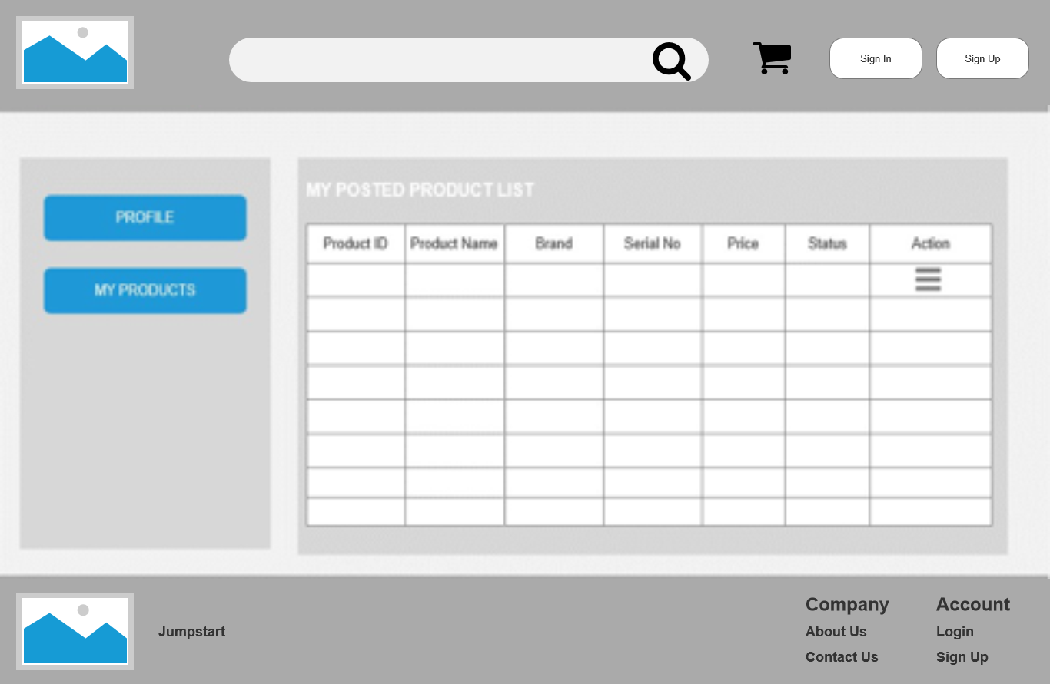 71

✓ Admin Product Management 72

✓ Cart – After Add Items 73

• Landing Page 74

• About Us 76

• Admin Product Management 77

• Cart After Add Items 79

• Edit Profile 81

• Partner Profile / User 83

• Post Product 85

• Registration Thank You 87

10. Project Implementation 91

• Landing Page 91

• About Us 93

• Admin Product Management 94

• Cart After Add Items 96

• Edit Profile 98

• Partner Profile / User 100

• Post Product 102

• Registration Thank You 104

11.1 Effectiveness and challenges of methods applied 105

✓ Effectiveness: 105

✓ Challenges 106

11.2 Alternative methods to overcome the challenges: 107

• Situational/behavioral interviews 107

• Work simulations 107

• Cognitive or psychometric testing 107

• Surprise/quirky questions 108

What the applicant says or does in an unexpected situation can reveal personality, motivation, ingenuity, and poise under pressure. According to Inc., unusual questions might "create a speak and flow the candidate away from rehearsed answers." You may ask a candidate what type of cheese best describes their personality or what superpower they would most like to have. The factor is not the actual answer, but rather how the candidate approaches the task of generating an answer. The answer will not be right or wrong, but will rather screen a candidate's ability to think on their feet and be imaginative when called upon. 108

✓ Survey 108

12.1 future research considerations: 111

# RESEARCH PART (PART I)

1. Introduction
   1. Research Background

The globalization of the market has presented organizations with both new opportunities and problems. Due to the rapid transformation, new digital marketing platforms and techniques are emerging in response to challenging circumstances such as the COVID-19 epidemic. These can help firms expand their market reach and achieve greater success. Changes in policy, market, company structure, and business enterprise way of life are employed in the process of digitization. When a digital machine is widely used in vending and business processes—including converting an offline supermarket into a virtual store—a thorough investigation and assessment are required to determine the system's modifications and capabilities and, as a result, change the store from the ground up.

* 1. Research Purpose

Aceadora Tech has been engaged as a website developer for the development. Jumpstart retail chain owns 750 shops nationwide. They attain out to the clients due to the excellent and creativity of their merchandise. A brand-new norm of faraway working has emerged in the submit-Covid19 disturbed their core enterprise in one of a kind respects. They need to reshape their business version and lean towards client trade. The project manager of JumpStart approached Aceadora Tech to provide the answer to overcome the challenges.

As a project manager I created e commerce website as a solution for this. E-commerce is fast gaining ground as an ordinary and used commercial enterprise paradigm. Increasingly commercial enterprise homes are enforcing web websites providing functionality for appearing business

Transactions over the net. Its miles reasonable to mention that the procedure of buying on the internet is turning into common.

The objective of this project is to increase a widespread-purpose e- commerce shop wherein any product (inclusive of books, CDs, computer systems, mobile phones, electronic items, cloths, domestic appliances and etc.) may be bought from the comfort of domestic thru the net.

An online store is a virtual store at the internet wherein customers can browse the catalog and pick products of interest. The chosen items may be accumulated in a shopping cart. At checkout time, the items inside the shopping cart might be supplied as an order. At that point, extra records might be wished to finish the transaction.

1. Literature Review

A literature review provides a detailed account of earlier studies on a particular count of concerns. An overview of the literature looks at books, instructional manuals, and specialized materials on a particular topic of interest. Within the evaluation, this previous test needs to be listed, explained, summarized, objectively assessed, and defined. It must provide a theoretical framework for the research and help you, the writer, define the parameters of your observations. A literature overview identifies the artwork of previous researchers, assuring the reader that you examine is well concept out. The author is deemed to have study, assessed, and mentioned previous art work near have a look at. A literature review creates a "panorama" for the reader by providing a thorough understanding of the advancements in the field. The reader is informed by this assessment that the author has undoubtedly incorporated all (or a significant portion) of the outstanding earlier works. The comparison, evaluation,

Literary complaints are evaluated based on the interpretation and/or evaluation of literary works. That is, a viewpoint backed up by facts typically related to a subject, literary form, historical period, or political or ancient setting. Evaluation articles on stock management, virtual transformation, and remote employment.

*Pdfdrive.com*

*Scholar.google.com*

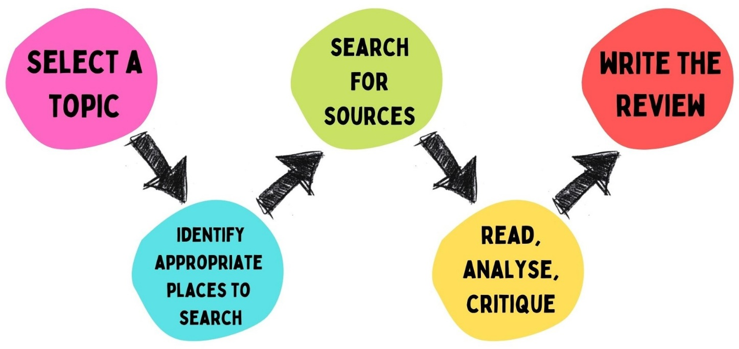

# Research Plan

1. **What is Research?**

"Creative and systematic work undertaken to increase the Inventory of information" is what research is defined as. It entails the assembly, companionship, and assessment of evidence to advance a subject's knowledge, distinguished by a special focus on counteracting bias and errors. Biases are taken into account and controlled for in those activities. Within the area of studies, assignments might cover more ground than just paintings. Research may also incorporate components of previous projects or the project as a whole to evaluate the validity of tools, procedures, or experiments.

# What is its purpose?

The research proposal is your chance to explain the importance of your mission to organizations who would possibly wish to fund or otherwise guide it. Preferably, it'll demonstrate the best and significance of your challenge as well as your capacity to conduct the proposed research. The suggestion also offers you the opportunity to assume through your research task, to refine your attention, and to be expecting any challenges which could rise up. It may be useful to seek advice from your notion at diverse levels on your research manner to remind yourself of your focus and to chart how your task has advanced.

# What is its significance?

The significance subsection will—

* Give an explanation for the importance of the problem or essential barrier to development within the area that the proposed project addresses.
* Explain how the proposed project will improve scientific information, technical functionality, and/or clinical exercise in a single or greater wide field.
* Describe how the principles, methods, technologies, treatments, services, or preventative interventions that pressure this discipline could be modified if the proposed aims are performed.
* State whether or not there is a strong scientific premise for the project.

# Research Philosophy

# Saunders's Onion Theory

The research onion turned into developed by way Saunders et al. (2007). It illustrates the stages that need to be covered while growing a research approach. Whilst considered from the doors, each layer of the onion describes a greater specified stage of the research manner (Saunders et al., 2007).

"The research onion is an illustrative model, developed through Saunders et al, to explain the ranges thru which a researcher should progress to formulate an effective methodology"

The research onion affords a powerful development through which a study’s methodology may be designed. Its usefulness lies in its adaptability for almost any form of study technique and can be utilized in a selection of contexts (Bryman, 2012).

# Stages of Saunders’s Onion Theory

The onion is made up of 6 layers, which you’ll need to peel again one by

One as you expand your research methodology

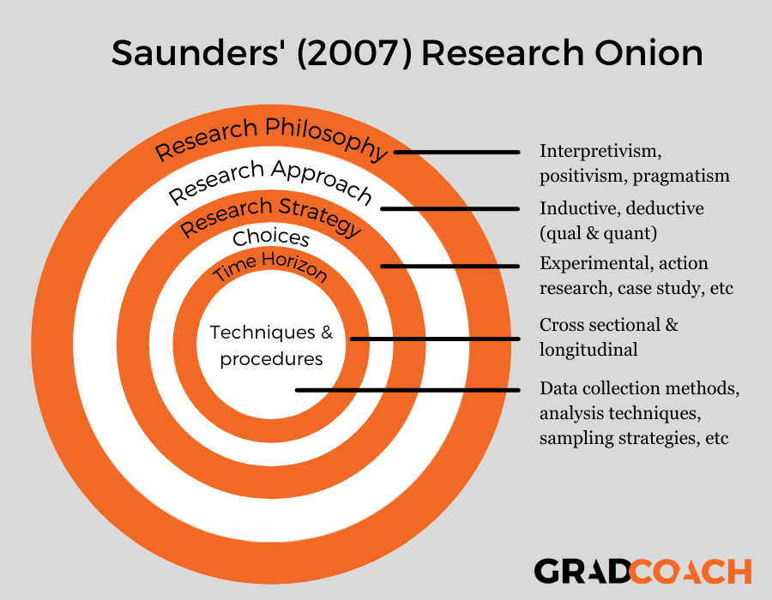

1. [**Research philosophy**](https://gradcoach.com/saunders-research-onion/#1)

It refers to the collection of ideas about the worldview or viewpoint from which the research is conducted. It also encompasses ontology and epistemology studies. Ontology refers to the authenticity of the statistics and how one becomes acquainted with its lifestyles, whilst epistemology refers to the legitimate records necessary for the investigation and how to obtain them. Philosophical positions commonly used in instructional research are positivism and interpretivism, with positivism assuming that understanding is unbiased of the problem being studied and interpretivism claiming that character observers have their own beliefs and knowledge of reality. As a result, positivist research is frequently more scientific and results in testing phenomena, whereas interpretive research is frequently qualitative in nature.

1. [**Research approach**](https://gradcoach.com/saunders-research-onion/#2)

Deductive and inductive are the 2 terms that the second layer of the study’s onion includes. Right here, the preceding layer of the onion has an impact in this one so it is critical to know the study’s goal and its limitations.

# The Deductive Approach

The deductive approach develops the speculation or hypotheses upon a pre- existing principle after which formulates the research method checks it (Silverman, 2013). The deductive approach may be taken into consideration especially suitable to the positivist approach, which allows the method of hypotheses and the statistical checking out of predicted results to a time-honored stage of possibility (Snieder & Larner, 2009). it's far characterized as the development from preferred to precise: the overall principle and knowledge base is first established and the particular expertise received from the studies technique is then tested towards it (Kothari, 2004). however, a deductive method may also be used with qualitative studies techniques, although in such instances the expectations shaped through pre-present studies might be formulated in a different way than via speculation testing (Saunders et al., 2007). The deductive method makes use of questionnaire to create know-how of observation which allows you to examine the special expertise of humans thru empirical statistics. The records accumulated enables to verify or reject the question, the technique can be repeated.

# The Inductive Approach

The inductive approach lets in so as to create a concept in preference to undertake a pre-present one as inside the deductive. This without a doubt outlines the distinction within the two strategies. The inductive approach is characterized as a circulate from the unique to the overall (Bryman & Bell, 2011). There may be no framework that first informs data collecting in this technique, and the research mindset might therefore be fashioned after the material has been obtained (Flick, 2011). Despite the fact that this may be obvious because the factor at which new theories are developed It is also true that as knowledge is generated, it might be discovered to fit into an existing idea (Bryman & Bell, 2011). This method is frequently employed in qualitative research. Interviews are conducted reporting unusual incidents, and the data are then examined for patterns among respondents (Flick, 2011).But this method can also be used efficiently inside positivist methodologies, where the information is analyzed first and great styles are used to inform the technology of effects

1. [**Research strategy**](https://gradcoach.com/saunders-research-onion/#3)

The research strategy describes how the researcher intends to carry out the paintings (Saunders et al., 2007). The method can include some of one of a kind approaches, which include experimental research, action research, case observation studies, interviews, surveys, or a scientific literature assessment

# Experimental

Experimental research is the strategy of developing a research technique that compares the findings of a test to the expected results. It is applicable to all areas of research and typically includes the assessment of a significantly limited number of factors (Saunders et al., 2007).

# Survey

The survey strategy of the research onion is frequently related to the deductive method. Its miles one of the best and low-cost research strategies. You could collect rich and reliable data via this approach. Surveys tend to be utilized in quantitative studies projects and contain sampling a representative share of the populace (Bryman & Bell, 2011). The Survey method is more often than not used to examine contributing

Variables among specific facts. It lets for the collection of substantial data with the purpose to be used to reply to the study's question.

# Case Study

This strategy focuses on one or more people or a particular area. It can provide a perception of the specific nature of any case and can establish the significance of way of life and context in differences between instances (Silverman, 2013). This method is more advantageous in economic research. Case observation studies are evaluations of a single unit with the goal of establishing important functions and drawing generalizations (Bryman, 2012). This type of study is useful in economic research, such as assessing the influence of funding in different situations or reviewing the reviews of two firms.

1. [**Choices**](https://gradcoach.com/saunders-research-onion/#4)

This is the fourth layer of the research onion; it is also referred to as research desire. This residue helps you to know whether or not it's far great to combine each quantitative and qualitative technique or to apply the simplest method. According to Saunders et al (2007), there are 3 mentioned choices in the studies onion that includes the mono, combined, and multi-method research choice or method.

* + Mono Method
  + Mixed Method
  + Multi-Method

1. [**Time horizon**](https://gradcoach.com/saunders-research-onion/#5)

The time horizon describes the required time for the final touch of the project work. Two sorts of time horizons are detailed in the research onion: the cross-sectional and the longitudinal (Bryman, 2012).

# Cross Sectional

The cross-sectional time horizon is the one already installed, wherein the information ought to be accumulated. This is used whilst the research is involved with the look at a selected phenomenon at a particular time.

# Longitudinal

A longitudinal time horizon for data series refers to the collection of statistics repeatedly over a prolonged period and is used in which a vital factor for the studies is inspecting change through the years (Goddard & Melville, 2004).

1. [**Techniques & procedures**](https://gradcoach.com/saunders-research-onion/#6)

Finally, we attain the center of the onion – that is where you get down to the actual practicalities of your research to make choices regarding precise strategies and procedures.

Specifically, this is wherein you’ll:

* + Determine what facts you’ll collect and what records collection methods you’ll use (as an example, will you operate a survey? Or possibly one-on-one interviews?)
  + Decide how you’ll pass approximately sampling the population (for example, snowball sampling, random sampling, convenience sampling, and so forth).
  + Decide the form of records analysis you’ll use to answer your research questions (together with content material evaluation or a statistical evaluation like correlation).
  + Installation of the substances you’ll be the use your look at (which

Includes writing up questions for a survey or interview)

# Gantt chart and Work Breakdown Structures (WBS) for Research Proposal

* + 1. **Project Plan**

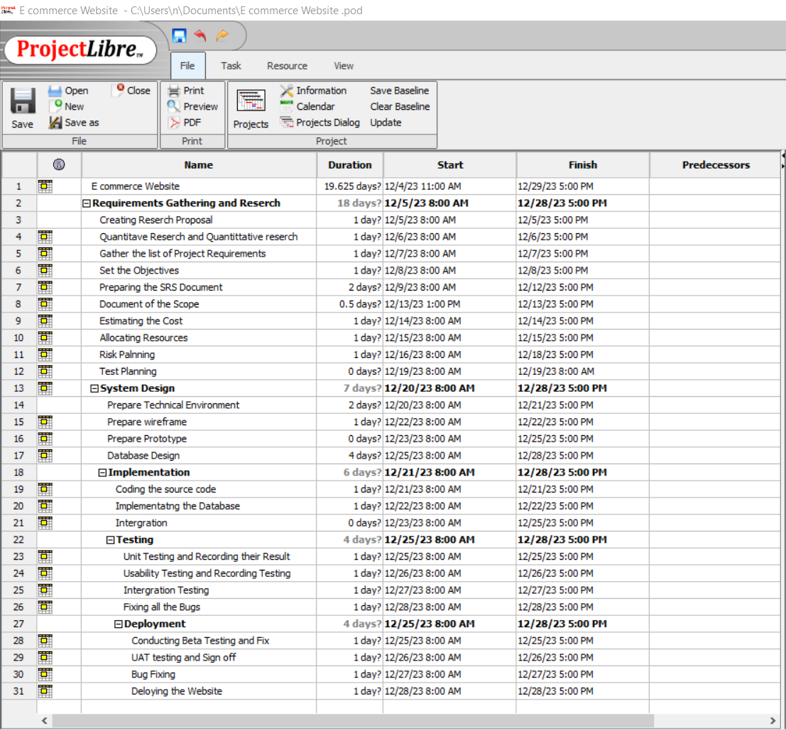

# Gantt Chart

A Gantt chart, generally utilized in project control, is one of the maximum popular and beneficial methods of displaying activities (tasks or events) displayed against time. On the left of the chart is a list of the activities and along the top is a suitable time scale. Each interest is represented by means of a bar; the location and length of the bar reflects the begin date, period and stop date of the activity. This lets in you to peer at a glance:

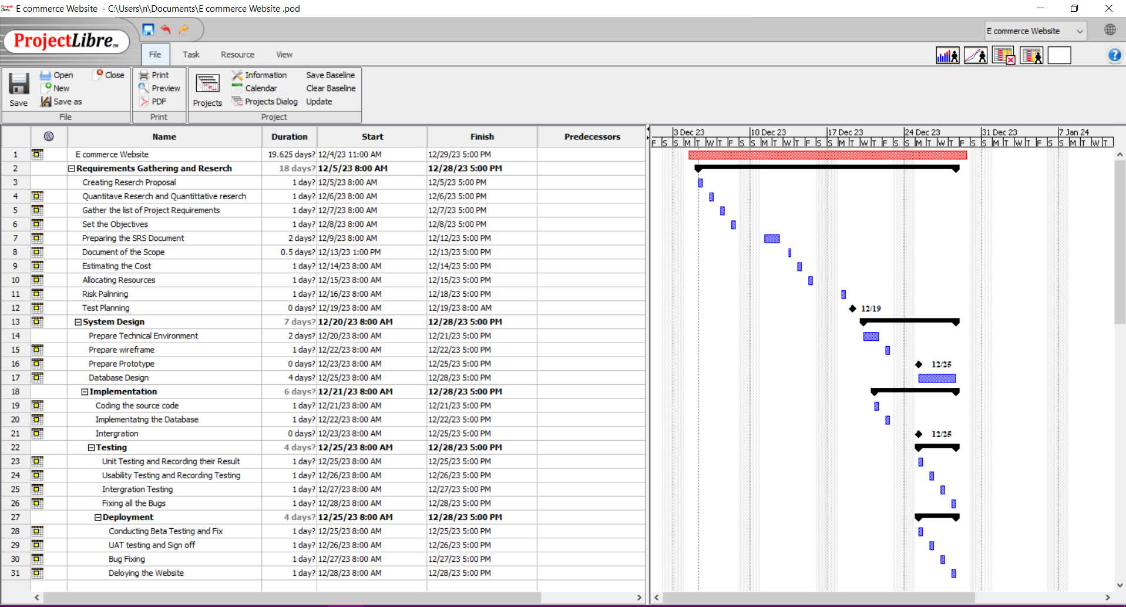

# WBS

A work-breakdown structure in project management and systems engineering is a deliverable-orientated breakdown of a task into smaller components. A work breakdown shape is a key undertaking deliverable that organizes the group's work into plausible sections

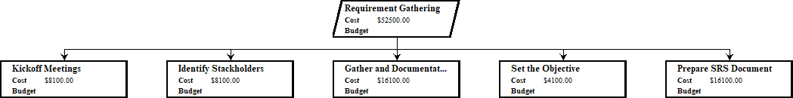

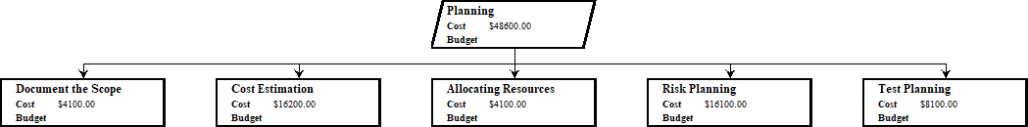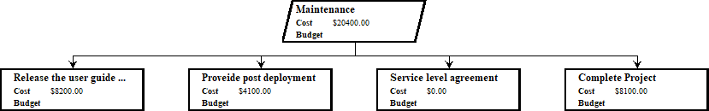

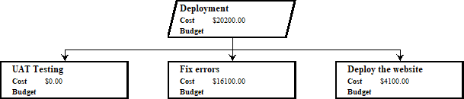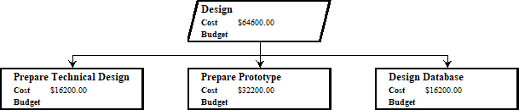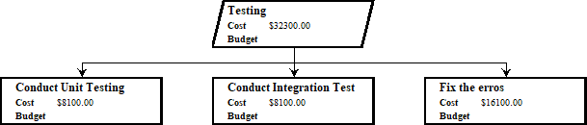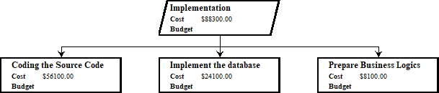

# Research Methodologies

A research methodology is an define of the tactics, techniques, and techniques employed in a research observe for the gathering, analysis, and interpretation of statistics. Studies papers incorporate a section committed to the research methodology of the look at conduct.

# Primary Research

Primary research is defined as a technique utilized by researchers to collect records at once, in preference to depending on statistics accumulated from previously finished research. Technically, they “own” the facts. Primary research is only completed to deal with certain trouble, which requires in- depth analysis

# Types of Primary Research

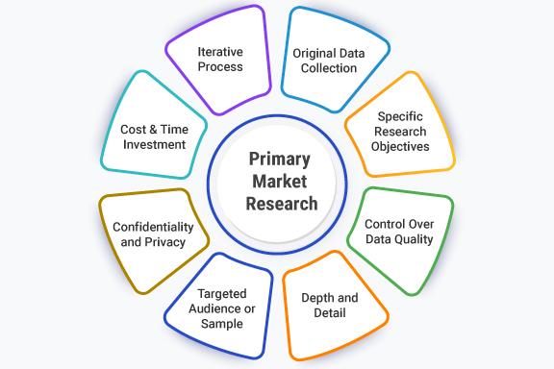

* + - * **Interviews (telephone or face-to-face)**

# Conducting interviews is a qualitative research method that has long been used to obtain statistics. These interviews can take place in person (face-to-face) or over the phone. Interviews are an open-ended strategy that involves conversations or interactions between the interviewer (researcher) and the interviewee (respondent).

# Surveys (online or mail)

As soon as carried out with pen and paper, surveys have come in an extended manner for the reason that then. Nowadays, maximum researchers use online surveys to send it to respondents to gather facts from them. Online surveys are convenient and may be dispatched via email or can be stuffed out online. Those can be accessed on handheld devices like telephones, tablets, iPad, and similar gadgets.

# Focus groups.

This common research technique is used to obtain statistics from a small group of people, usually six to ten. The awareness institution brings together individuals who are experts in the subject count number being studied.

The focus institution has a moderator who facilitates discussions with several of the members in order to gain further insights. Organizations and agencies can use this strategy to become aware of a specific market and learn about a specific group of clients.

# Observation

Observation as a number one studies approach happens anyplace a person establishes a particular set of criteria, capabilities, or traits after which examines something for the ones traits or features.

# Merits/ Demerits of Types of Primary Research

|  |  |  |
| --- | --- | --- |
| Type | Merits | Demerits |
| Interviews | * Ability to locate the appropriate applicant * Enables exact evaluation * Excellent source of information * Identify Knowledge * Improved understanding of stakeholders | * Fairly time-consuming * Chance of personal bias * Quick to choose * Can easily shape stereotypes * Hard to affirm the truth |
| Surveys | * Relatively simple to maintain o Can evolve in considerably less time (when compared to other statistics-series methods) * Cost-effective, however costs vary depending on survey method * Can be managed remotely via the internet, mobile devices, mail, email, kiosk, or smartphone. * Remote execution can decrease or eliminate geographical dependence. | * Respondents will not feel encouraged to provide correct, truthful solutions. * Respondents will not feel comfortable proposing ideas that benefit themselves in a negative way. * Respondents may be unaware of their motivations for any particular solution due to a loss of recall about the circumstance or boredom. * Surveys with closed-ended questions may have a lower validity rate than other inquiry types. |
| Focus Groups | * Insightful data * Frame language observations * Low prices * Emotional connections | * Time-consuming evaluation * Participants are shy * Individuals are willing to present records * Difficulty in enticing a massive institution |
| Observation | * View operations of a software as they're simply occurring * Can adapt to occasions as they arise | * It can be difficult to interpret observed behaviors. * Observations can be difficult to categorize. |

* Can have an effect on behaviors of software participants
* Can be highly-priced
  1. **Secondary Research**

Secondary research comprises summarizing, collating, and/or synthesizing current findings. Secondary research differs from primary research in that primary research involves the generation of knowledge, whereas secondary research employs primary research assets as a source of records for analysis. The inclusion of a "strategies" section, in which the authors detail how the statistics were created, is an excellent indicator of original research.

# Types of Secondary Research

* + - * **Static Analysis**

There is sufficient data available online from a ramification of sources, often within the shape of datasets. These datasets are often open- supply or downloadable at a low price, and are perfect for undertaking statistical analyses inclusive of speculation trying out or regression evaluation.

Credible assets for current statistics consist of:

* + - * + The government
        + Government companies
        + Non-governmental corporations
        + Instructional institutions
        + Businesses or consultancies
        + Libraries or data
        + Newspapers, educational journals, or magazines

# Case Study

A case study is an in-depth examination of a specific problem. It is also qualitative in nature and can be used to identify a person, group, location, event, business, or phenomena. A case study is an excellent way to use current research to get concrete, contextual, and in-depth knowledge about your real-world situation.

You could pick out to attention on simply one complicated case, exploring an unmarried issue in exceptional element, or observe multiple instances in case you’d prefer to compare special aspects of your subject matter. Preexisting interviews, observational research, or different resources of primary records make for extremely good case research.

# Literature Review

A literature review is a review of previously published scholarly sources on your topic. It provides an overview of current material, helping you to identify pertinent issues, controversies, and gaps within the papers you examine. You can later use those to your own job or utilize them as a springboard to undertake your own number one research.

Based just like a normal instructional paper (with a clear creation, body, and conclusion), a literature overview is an outstanding manner to evaluate the contemporary nation of studies and exhibit your information of the scholarly debates around your topic.

# Content Analysis

Content analysis is a research approach that studies styles in recorded conversation with the aid of making use of current texts. It is able to be

Either quantitative or qualitative in nature, relying on whether you pick out to analyze countable or measurable patterns or greater interpretive ones. Content evaluation is famous in communique studies, but it's also widely utilized in historic evaluation, anthropology, and psychology to make extra semantic qualitative inferences.

# Sources of data

Data sources are true sources of information. It has two grant components: internal and external resources. Primary records are data obtained from internal sources, whereas secondary facts are information gathered from external sources. The data sources are clearly mentioned in the table below.

* Public Library
* Online Material
* Gov/Non-gov agencies
* Commercial Sources
* Magazines
* Newspaper
* Journals
* Articles, etc.

# Merits/ Demerits of Secondary Research

|  |  |
| --- | --- |
| Merits | Demerits |
| * Secondary facts could be easily obtained and efficiently obtained. * It is also frequently free or accessible via your academic institution's library or network, making it much less expensive to practice than primary studies. * As you are relying on research that already exists, undertaking secondary research is a great   deal much less time eating than | o Ease of access does not indicate credibility. It is crucial to remember that secondary research is not always consistent and may frequently be out of date. Before you begin, it is necessary to assess any statistics you are considering employing, utilizing a process such as the CRAAP examination. |

|  |  |
| --- | --- |
| primary studies. Since your timeline is a lot shorter, your research can be ready to publish sooner.  o The usage of information from others allows you to expose reproducibility and replicability, bolstering prior research and situating your  own work within your area. | o Secondary studies are frequently based on main research that have already been completed. If the original study is prejudiced in any manner, those biases should be reflected in the secondary results. |

1. **Research Approaches**

There are three key approaches that are commonly used in research and they are:

# Quantitative Research

* + 1. **Quantitative Research Methodology**

The quantitative research method is employed whilst the data being accrued is quantifiable and may be used to perform mathematical, statistical, or computational techniques. a few normally used quantitative methods of information series are surveys, online polls, and questionnaires.

A few characteristics of quantitative research are

* Quantitative Data
* Closes-Ended Questions
* Large Sample Size
* High External Validity

# Merits/Demerits of Quantitative Research

|  |  |
| --- | --- |
| Merits | Demerits |
| * Can be tested and checked * Straightforward analysis * Prestige | * False focus on numbers * Difficulty setting up a research * Can be misleading |

* 1. **Qualitative Research**

# Qualitative Research Methodology

Qualitative research is typically concerned with textual records and focuses on words and their meanings. When this methodology is used, statistics are gathered through open-ended and conversational conversations. Qualitative studies are increasingly being employed in market research because firms want to understand not just what their customers are doing but also why they are doing it. This enables companies to have a thorough understanding of their target market, allowing them to implement effective advertising campaigns.

A few characteristics of qualitative research are;

* Open-Ended Questions
* Complex Reasoning

# Types of Qualitative Research Methods

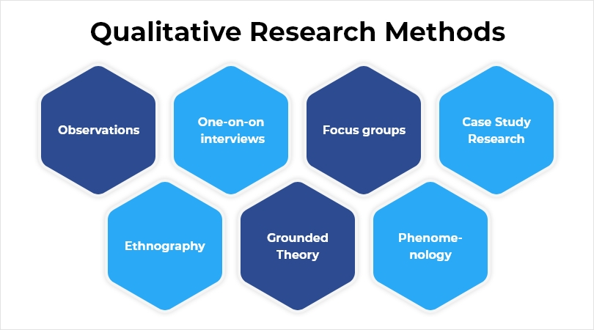

* + 1. **Merits/Demerits of Qualitative Research**

|  |  |
| --- | --- |
| Merits | Demerits |
| * Possible to understand attitudes * Content Generator * Save Money * Allows creativity to be a driving force * Open- ended * Incorporates the human experience | * Not a statistically representative form of data collection * Relies upon the experience of the researchers * Can create misleading conclusions * Can be influenced by researcher bias |

|  |  |
| --- | --- |
| * Can provide insights that are specific to an industry | * Can lose data * It may require multiple sessions * Can be difficult to replicate results |

# Mixed Methods Approach

As the name suggests, the blended method approach uses elements of both, the quantitative research method and the qualitative studies methodology. Through combining the two, the blended-methods method helps produce a extra complete and holistic photo than a quantitative or qualitative study in my opinion

# Research Design

* 1. **Saunders Research Onion Theory**

Saunders' (2007) research Onion – what is it? At the handiest level, Saunders' research onion describes the distinct selections you'll want to make whilst growing a studies method – whether or not this is for your dissertation, thesis or some other formal research challenge.

# Compare among research methods and research approaches

* + 1. **Comparison of data Approaches**

|  |  |  |  |
| --- | --- | --- | --- |
|  | Quantitative Research | Qualitative Research | Mixed Research |
| Nature of data | Variables | Words, Images, categories, patterns | A mix of variables, words, images |
| Data Analysis | Statistical relationship | Search for patterns, themes and holistic features | Quantitative symptoms and qualitative support |
| Results | Generalizing | Particularistic finding representation of insider | Corroborated findings may generalize |
| Final Report Form | Statistical report | Narrative even with direct quotations of research participants | Eclectic and pragmatic |

Conclusion: Choose the best approach and write the reason for choice.

# Comparison among primary methods:

|  |  |  |  |
| --- | --- | --- | --- |
| Survey | Interview | Focus group | Observation |
| Surveys are a cost-powerful approach of sampling a massive institution of human beings. They involve a series of  smooth to | An interview is a qualitative research technique used to accumulate primary statistics. It includes asking one or more  humans | A focus group is a research method that brings collectively a small group of humans to answer questions in a  moderated | Primary data are original observations amassed by way of the researcher or via his agent for the first time for any  research and |

|  |  |  |  |
| --- | --- | --- | --- |
| answer questions which can be generally multiple desire. This permits quantitative statistics to be accrued and analysed with the aid of the researcher. | approximately their opinions on a organization, a product, or a topic. | putting. The institution is chosen due to predefined demographic tendencies, and the questions are designed to shed mild on a topic of hobby. It's far considered one of 4 forms of  interviews | it's miles series of records from first hand data. This type of primary data is generally pure and authentic data. |

**Conclusion:**

# Because this is an e commerce online purchasing site, I believe that the ideal primary method is a survey. eCommerce businesses have a lot to learn about their consumers' wants, needs, and incentive to purchase for, all of which vary. The survey results can be used to optimize the website, improve the shopping experience, change corporate practices, and so on.

#  Helps with data collection

On line shopping surveys are incredible for collecting information about clients, their motivations, shopping conduct, necessities, and so forth. You'll get to recognize approximately their demanding situations, experiences, and possibilities. You could accumulate data in actual-time using which you may make immediate changes for your commercial enterprise.

#  Better Customer Experience

While a customer buys from you one time and never stores from you again, you will never know what took place. Carrying out a survey as soon as they shop from you or a few months when they use your service is a super way to find out in the event that they were disillusioned with

whatever. You may take remediation steps at once to address them. It would work in your desire as they'll be thrilled which you solved the frictions that they faced whilst shopping. They could even recant on their choice of no longer purchasing from you once more.

#  Helps to improve market strategy

Can use the information gathered from the web shopping survey to understand in case your marketing strategy is on point. If you get to realize that a majority of your goal marketplace is on Instagram, via the survey, there’s your cue to trade your approach. You'll have a better expertise of your customers. It's going to additionally help you create content material for every section so you hit the proper nerves.

# Comparison of secondary methods

|  |  |  |  |
| --- | --- | --- | --- |
| LR/document analysis | Grounded Theory | Case Study | Ethnography |
| Secondary literature comprises views and opinions developed from or in agreement with primary supply material. Examples include review articles (including meta-analysis and systematic views) and reference works.  Document analysis is a shape of qualitative research in which files are interpreted with the aid of the researcher/assessor to  give voice and that means round an | Grounded theory is well utilised in qualitative research for building theoretical know-how of complicated social techniques.  Grounded idea facts analysis strategies can be used with specific forms of facts, along with secondary information | The researchers describe the analysis of secondary case research as the usage of existing case studies so one can cope with a research query that is consistent with, however differs from the motive of the unique case have a look at [14]. the selected cases  offered | Ethnographic methods are a research approach wherein you have a look at humans in their cultural setting, with the purpose of producing a narrative account of that particular way of life, against a theoretical backdrop |

|  |  |  |  |
| --- | --- | --- | --- |
| assessment subject matter. Analyzing documents consists of coding content into issues, just like how attention institution or interview transcripts are  analyzed. |  | evidence based totally on actual commercial enterprise experiences. |  |

**Conclusion**

Document analysis, in my opinion, is the best secondary method because it is useful for information coverage content material across time and geographies, documenting procedures, triangulating with interviews and other data resources, understanding how records and thoughts are provided officially, and understanding problem framing, amongst other things.

# Research Conduct and Analysis

* 1. **Conduct Primary Research**

**Survey:** complete process of conducting survey:

1. Consider costs, access and ethical issues

|  |  |
| --- | --- |
| Survey Considerations | Description |
| Cost | Google Form is open-source tool to create the survey form. The participants only need to use the  internet to participate in surveys. |
| Access | Can access in anywhere internet access. |
| Ethical | Make sure that the participants  agree the consent to do the surveys. All the data are kept as confidential. |

# Objective of survey

To comprehend by researching Jumpstart Pain points during COVID 19 and to be aware of the actual or full requirements for the deaired solution

# Identify the tool

I decided to create the poll with Google Forms because Google Forms is a survey administration software program protected as part of the free, web-based entirely Google Docs Editors suite provided by Google. Google Docs, Google Sheets, Google Slides, Google Drawings, Google Websites, and Google Keep are also part of the service. Google Docs is only available as an internet application.

1. **Frame question** for survey:

* **Pre-Survey -** https://forms.gle/QGuMmax54hQ4Lb8A8

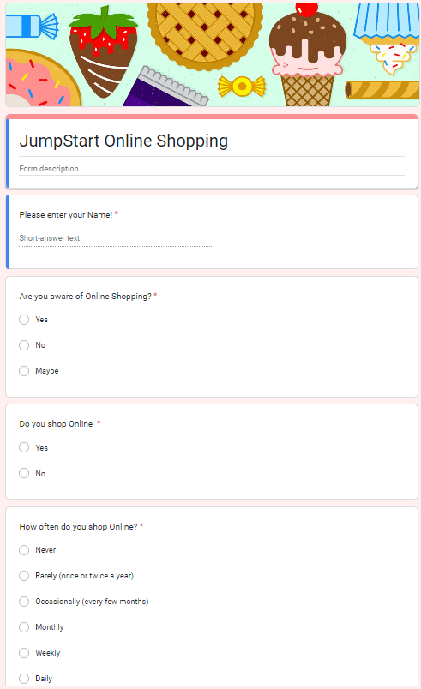

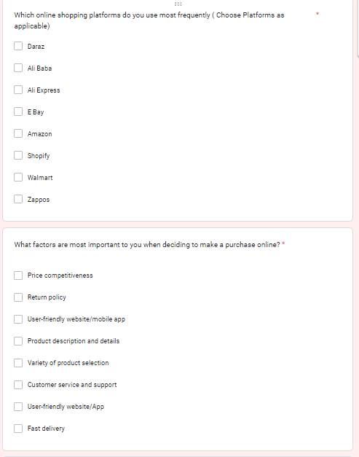

* **Collect and analyze results – Pre-Survey**

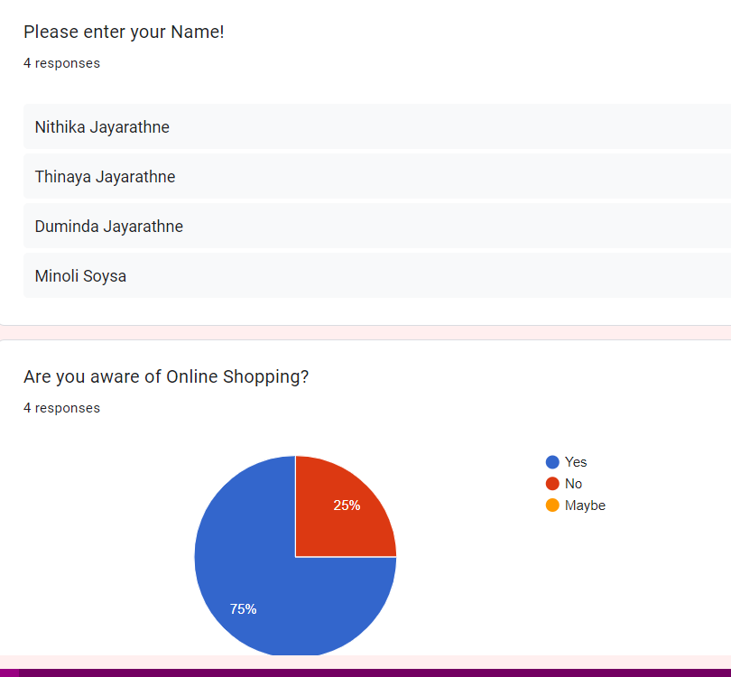

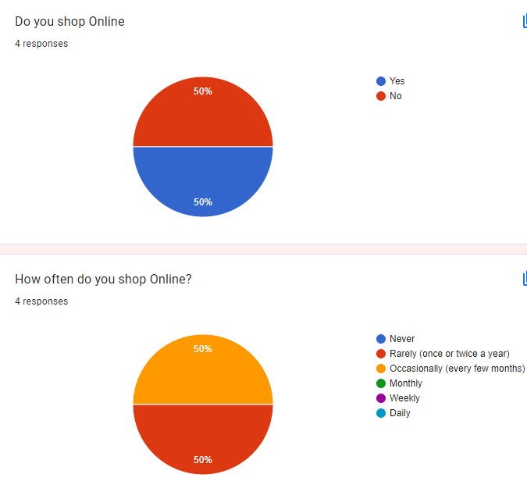

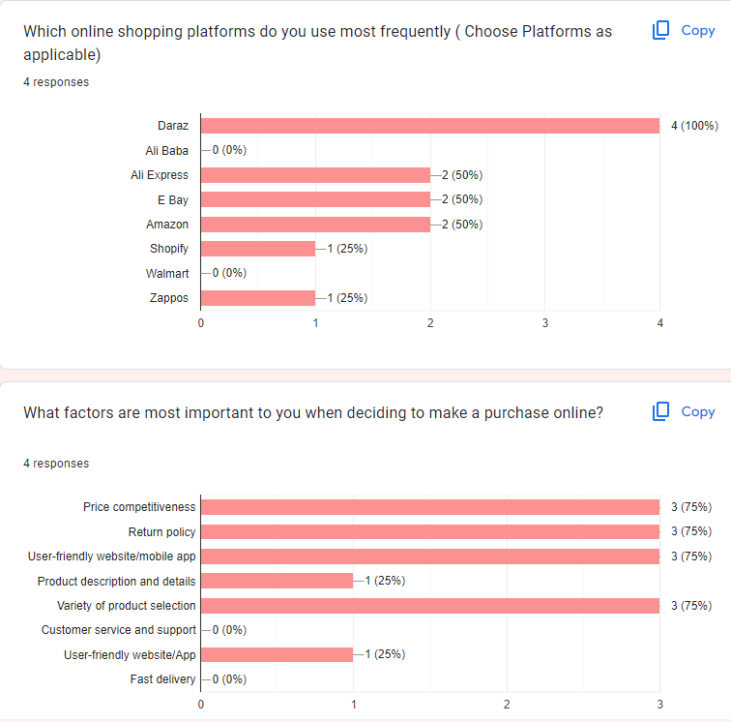

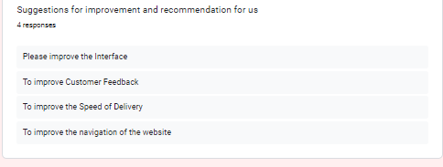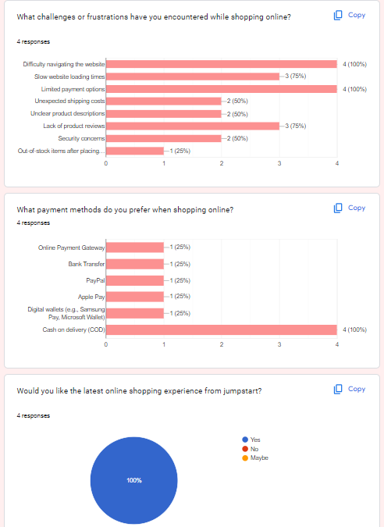

**Conclusion:**

According to the poll results, the majority of those people have been using the Jumpstart retail gadget for one or two years and visit Jumpstart stores at least once a week. In this challenging situation, many of them choose not to leave their homes and travel to the market. Some have previously used an appointment machine, while others have not. However, according to their findings, the contracted e-commerce system has security and compatibility issues.

# Conduct Secondary research (Identify Tools and techniques):

The issues in Jumpstart can be resolved with the use of increasing operational efficiency. Increasing operational efficiency may help the startup website technical aspects in certain ways. The projects goal is to provide Jumpstart with the best solution for their issues with remote working and design an E commerce system as a real solution. So by utilizing e commerce we can accomplish these goals and objectives. The scope of E commerce is buying and selling, advertising, servicing delivery and charge of products, carrier and information over net, intranets, extranets and other networks, between an inter-networked company and its potentialities, customers suppliers and different commercial enterprise companions and developing an improved e commerce site for the Jumpstart retail system website using Axure. Axure is a Axure is a collaborative web application for interface design, with additional offline features enabled by desktop applications for macOS and Windows.

|  |  |
| --- | --- |
| LR/Case study Considerations | Description |
| Cost | No cost / Open source |
| Access | Online Access |
| Ethical | Very much detailed and takes lots of time |

1. **Content analysis**

|  |  |  |  |
| --- | --- | --- | --- |
| **S. N**  **o.** | **Title** | **Reference Link** | **Outcomes** |
|  | Sunder’ s Onion Theory | https://thesismind.com/analy sis-of-saunders-research- onion/ | Understand about what are the layers of  sunder's onion theory and how to use it |
|  | Case Study | https://[www.bloomreach.com](http://www.bloomreach.com/)  /en/blog/2019/ecommerce- case-studies | General knowledge about the case study  and how is it done |
|  | Digital Transfor mation | https://egfound.org/projects/ digital-revolution-technology- power- you/?gclid=CjwKCAjwzuqgBh AcEiwAdj5dRvegY5GhoMxTou wHtEV9iHvazOVQEEODe7Blke 372V6bM7PY1QqqmhoCFV8Q  AvD_BwE | Get an idea about what is the digital transformation and hoe can use it for our project |
|  | Cart System | https://www.cs- cart.com/shopping-cart-  system.html | Good idea about what is a cart system and  how is it works |
|  | Quantita tive vs Qualitati ve | https://www.financestrategist s.com/wealth- management/fundamental- vs-technical- analysis/quantitative- analysis/?gclid=CjwKCAjwzuq gBhAcEiwAdj5dRppZQlAWtWP qjo_i8Y7ObLX_6wayaEgKa1n ELnksdjbXmKXXaF5gfBoCneM  QAvD_BwE | A good comparison of qualitative and quantitative methods and analyses of them |
|  | Researc h Methods | https://guides.lib.vt.edu/rese archmethods/design-method | Understand about the research methods and how they are  important in this project |

1. **Trend analysis**

Referring to the analysis of data gathered on various retail business developments and effects in the pre- during and after COVID 19

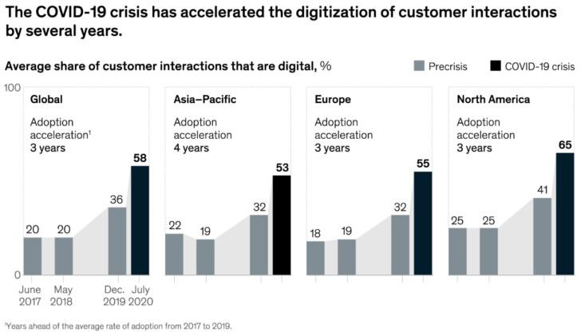

# Analysis of remote working before and after covid19

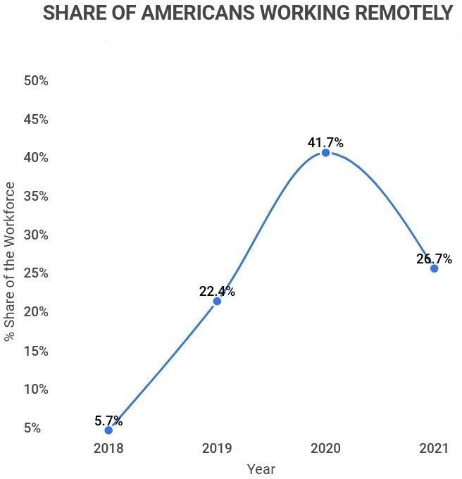

**Analysis of retail stores working during past days**

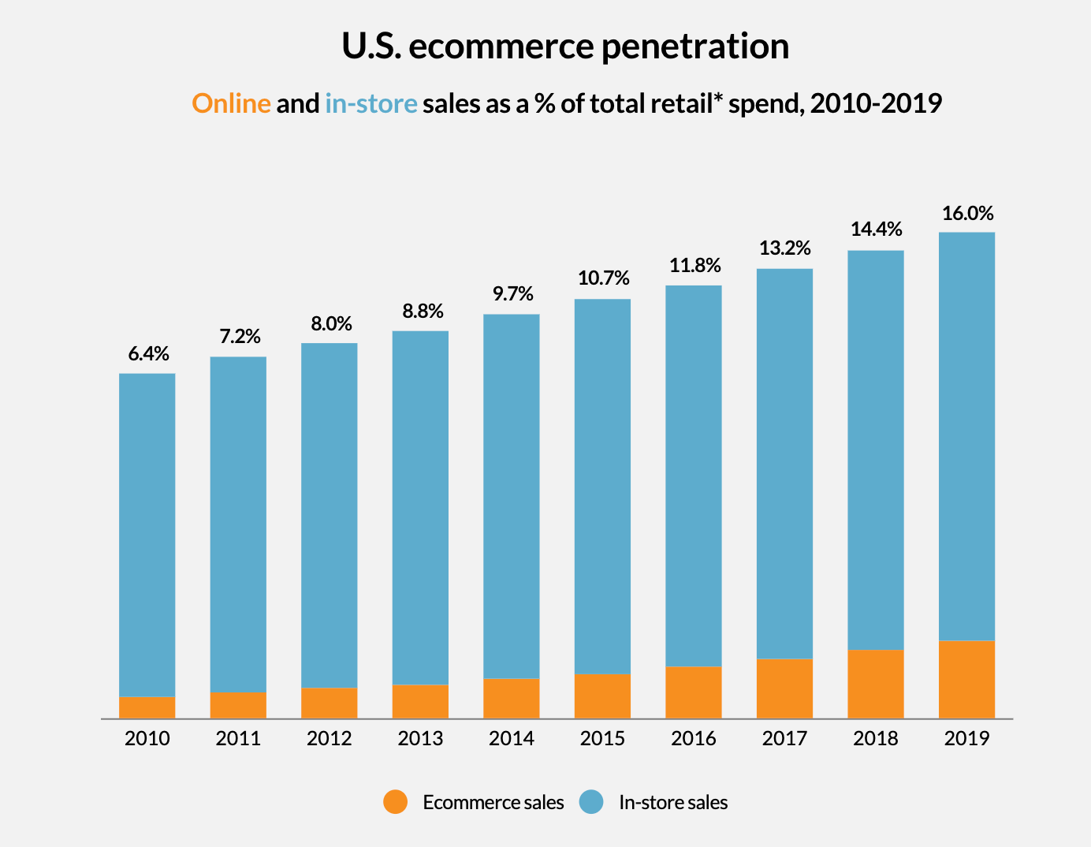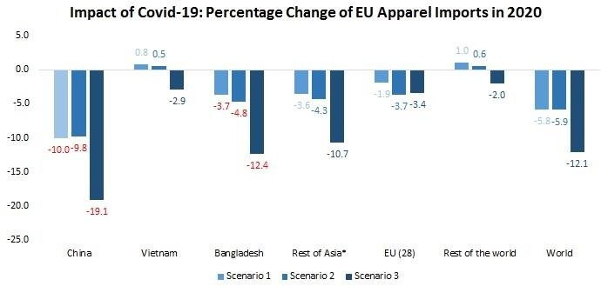

# Project Part (Part II)

1. **Project Proposal**

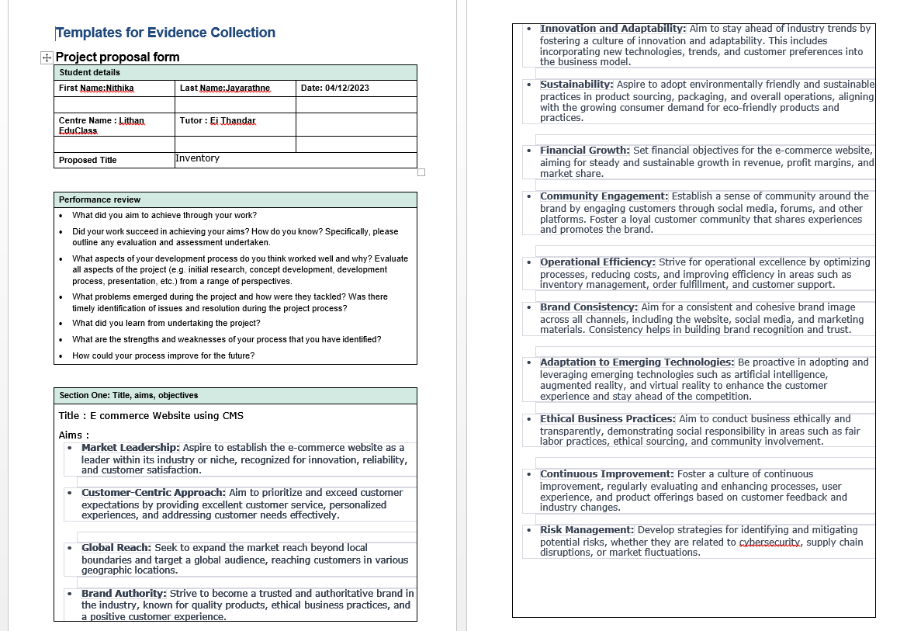

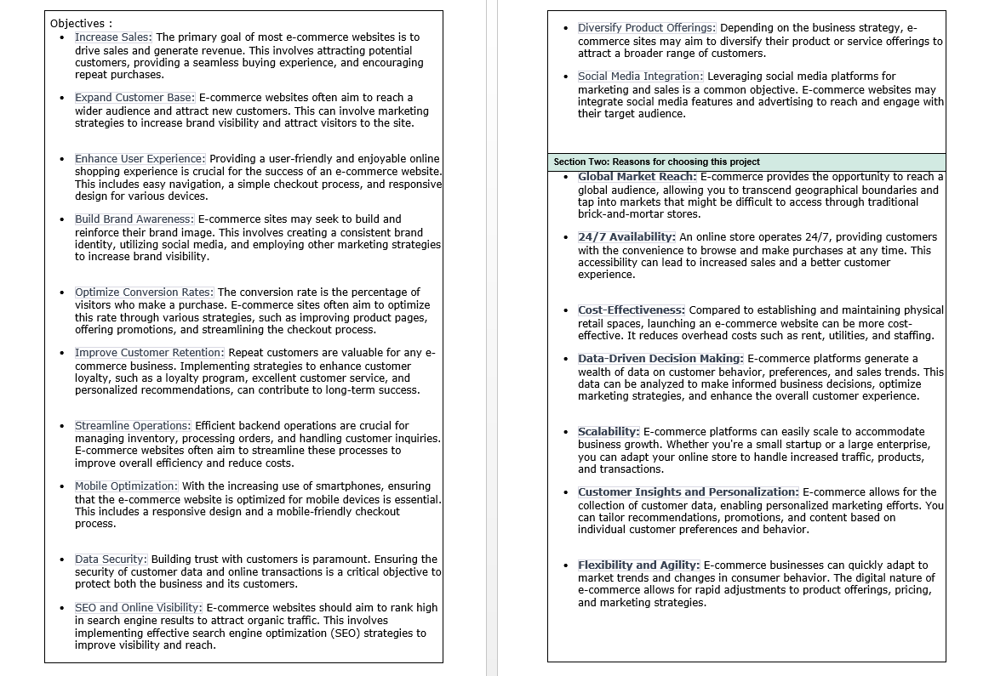

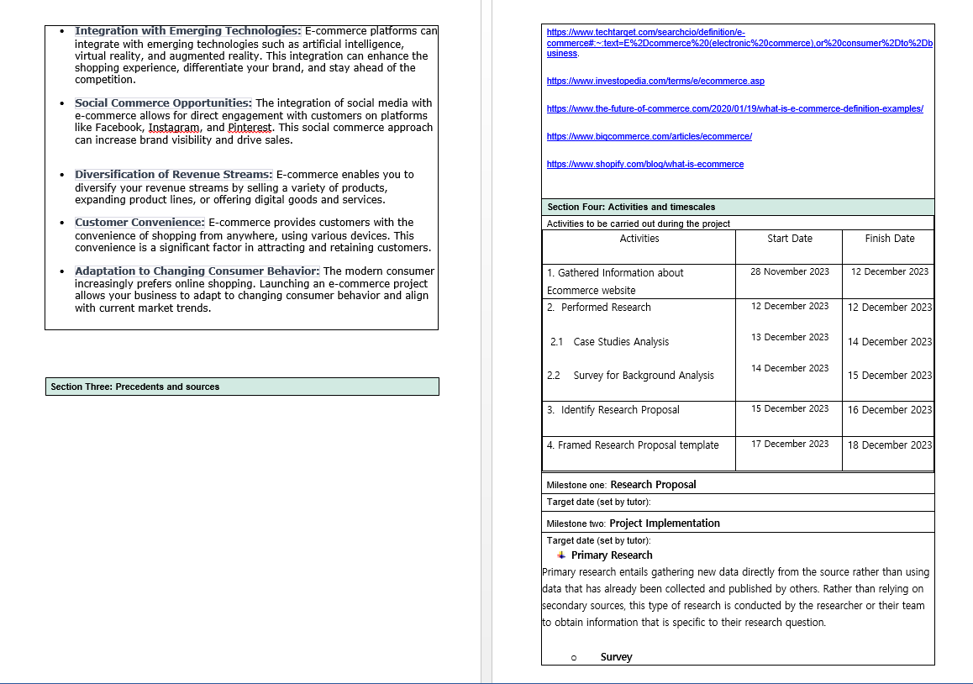

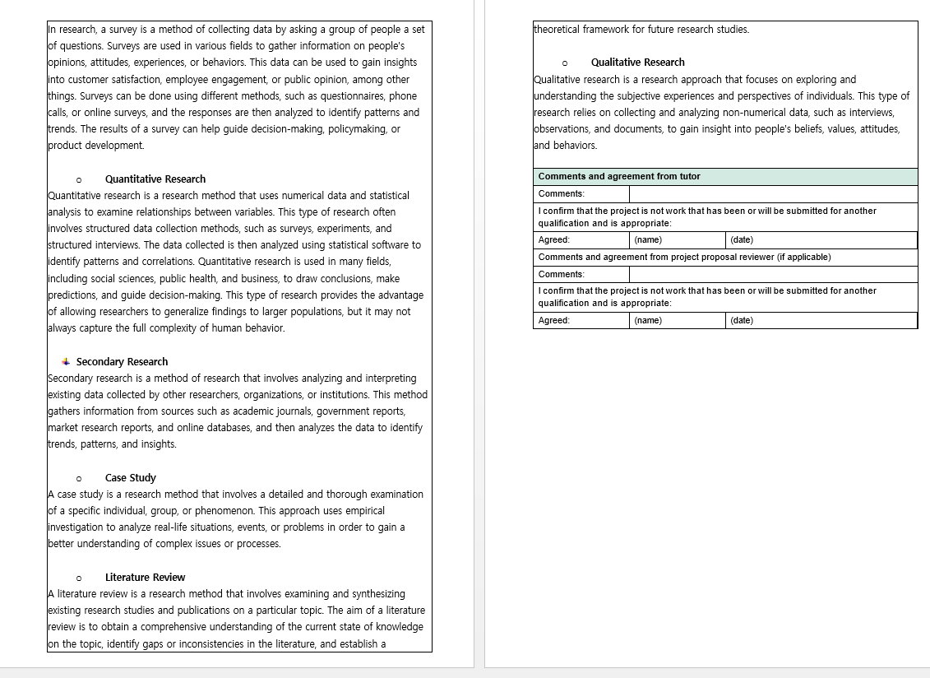

# Project Aim

The goal of the assignment is to digitally automate the garment saving process so that users can shop online from anywhere at any time. Using the application to manage the database is simple and convenient, saving time and resources.

# Objective

* Manage Online Selling Costs in A Strategic Way
* Establish Deeper Business Relationships
* Provide a Unique Customer Experience
* Improve Customer Loyalty
* Identify the Right Target Audience
* Increase the pace of operation of Jumpstart

# Responsibilities

* Designing and applying appropriate project control standards
* Discover the stakeholder list
* Adopting any delegation and use of project assurance roles within agreed reporting structures
* Making ready and keeping project, stage, and exception plans as required
* Handling project risks, which includes the improvement of contingency plans
* Monitoring overall progress and use of sources, initiating corrective action in which important
* Become aware of project goals and objectives
* Handling the production of the specified deliverables
* Making plans and tracking the project
* Making use of trade management and configuration control procedures
* Adopting and applying suitable technical and quality strategies and standards
* Figuring out and acquiring support and recommendation required for the control, making plans and control of the project
* Managing task management
* Conducting a project evaluation evaluate to assess how properly the project was managed
* Preparing any observe-on action recommendations
* Retaining an awareness of capability interdependencies with other initiatives and their effect

# Scope

The scope of this project includes the following:

* The implementation of a new software system
* Data migration from the old system to the new system
* Explain principles of problem management across its lifecycle.
* Use various tools, process and technologies to facilitate problem identification, investigation, analysis & resolution
* Explain various steps to investigate & diagnose problems.
* User training and support
* System maintenance and upgrades
* Document & monitor the problems
* Explain best practices in documenting problems
* Prioritize & Categorize change requests.
* Prepare a solution to address the root cause of the problem.

# Users should be able to perform the following functions in the portal

* + Register in the Portal
  + Login to the Portal
  + Add items to the cart
  + View cart items
  + Post a product for Sale along with a Picture Upload
  + Deactivate an Existing product
  + Update their Profile after logging in.

# Administrators should be able to perform the following functions in the portal

* + Register in the Portal
  + Login to the portal
  + Activate / Deactivate a product post
  + Update their profile
  + Transact the sales if the price is right
  + View the List of Registered Users/partners
  + Mark a User as Administrator

# Both Users & Administrator

* + Visit the Home Page
  + View product Listing
  + About Us Page
  + Contact Us Page
  + Terms & Conditions
  + Search for a product by Name, Brand, Serial No & Price Range

# Project out of Scope

* Upload the comments alternative and rating system to get the user’s

Thoughts.

* Develop FAQ pages to remedy the issues frequently requested by the customers.

# Enlist Assumptions

* **Budget Assumptions**
  + The overall cost of everyday operations will stay unchanged
  + The whole price range of the project will no longer exceed and may cover back the capital used.

# Resources Assumptions

* + Team members may have expertise on Spring Framework, MySQL database
  + All of the materials and equipment wished might be obtained and to be had for use when conducting the project
  + Time frame can be planned and created based totally on WBS
  + Every milestone could have its character issue and end date in the plan

# Scope Assumptions

* + The client will offer all brand records in line with the dates detailed in the schedule
  + Can use the modern business brand tips
  + Can use the modern guidelines

# Environment Assumptions

* + Will use the existing IT structure
  + Can be able to get making plans permission in a timely way
  + The facilities can be open at the weekend to permit the crew to do the project work
  + The records were routinely updated inside the data inventory, and all statistics within the information stock is synchronized.

# Need of Solution:

* + - Conduct assumption analysis for the risk administration plans to come up with a backup plan if the primary plan does not work, such as how to manipulate the lack of materials that may be deemed critical for the task, thus lowering the risk that can have an effect on the project's performance.
    - Always display all of the resources and keep track of the condition of the resources to ensure that the assets are within the acceptable cir
    - Continually monitor and take a look at the situation of the resources (gadgets, materials, or tools)
* Create short-term and long-term budgets to support the formulation of contracts, which will typically keep the whole project value within the budgeted value, preventing the Project from going above the real budget.
* Complete the project according to the schedule, and try to mitigate the impact if the timeline cannot be fulfilled by establishing a backup plan.
* When creating a software task, always consult with the software development life cycle (SDLC).
* Boost Sales
* Scalability

# Project Environment

* **Hardware Requirements**

|  |  |  |  |
| --- | --- | --- | --- |
| No | Hardware | | |
| **Type** | **Server** | Client |
| 1 | Processor | Intel(R) Core(TM) CPU@ 2.60GHz | Intel Core i5 |
| 2 | Memory | 32 GB | 8 GB |
| 3 | Hard Drive | 4 TB | 1 TB |
| 4 | Network | SLT Fibre Network | SLT Fibre Network |
| 5 | Monitor | Monitor 24” | Monitor 24” |
| 6 | Keyboard | USB Keyboard | USB Keyboard |
| 7 | Mouse | USB Optical Mouse | USB Optical Mouse |

# Software Requirements

|  |  |  |
| --- | --- | --- |
| No | Software | Functionality |
| 1 | Windows 10 | Operating System |
| 2 | Bootstrap, CSS, Spring Boot | Web Creation |
| 3 | MySQL | Database Server |
| 4 | Tomcat | Web Server |
| 5 | Axure | Design |
| 6 | Google Chrome, Microsoft Edge | Web Browser |

* **Network Requirements**

|  |  |  |
| --- | --- | --- |
| No | Network Device | Functionality |
| 1 | Switch | Cable connecting network from workstation |
| 2 | UTP Cable | Connecting Medium |
| 3 | RJ 45 Connector | Cable connecting network with LAN Card |

# Cloud Requirements

 AWS

 Azure

# Skills and Human Resources

|  |  |  |
| --- | --- | --- |
| No | Requirements | Skills |
| 1 | UI/UX Designer | Axure |
| 2 | Web Developer | HTML, CSS, JavaScript, Bootstrap, Spring Boot Java, MySQL. |

* 1. **Project Blueprint**

# Flow charts

* **Admin**

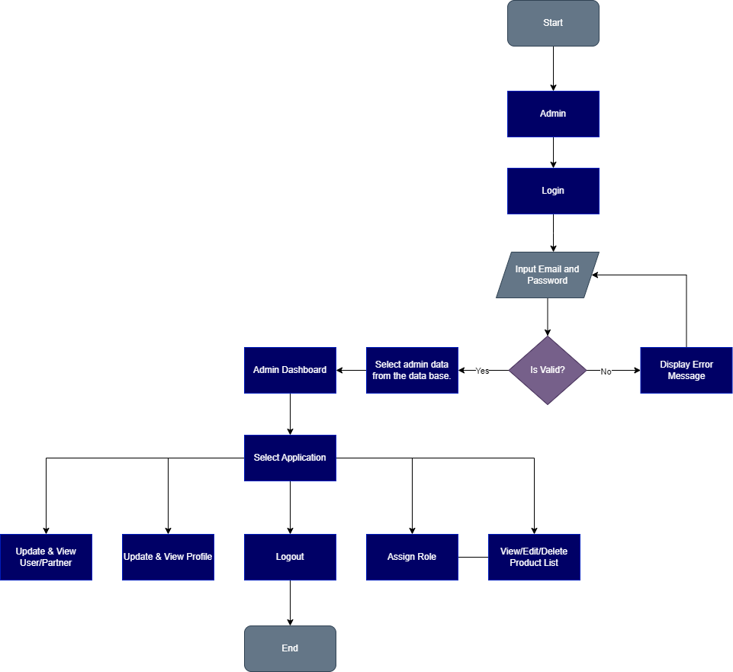

# Login

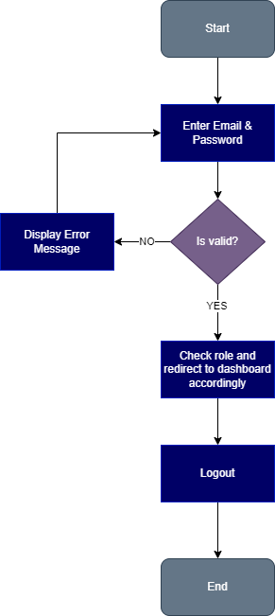

* **Registration**

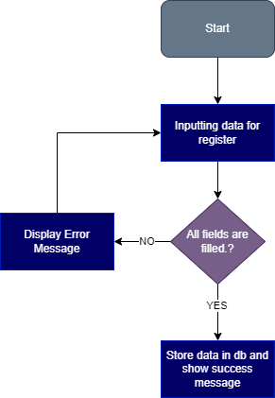

# User

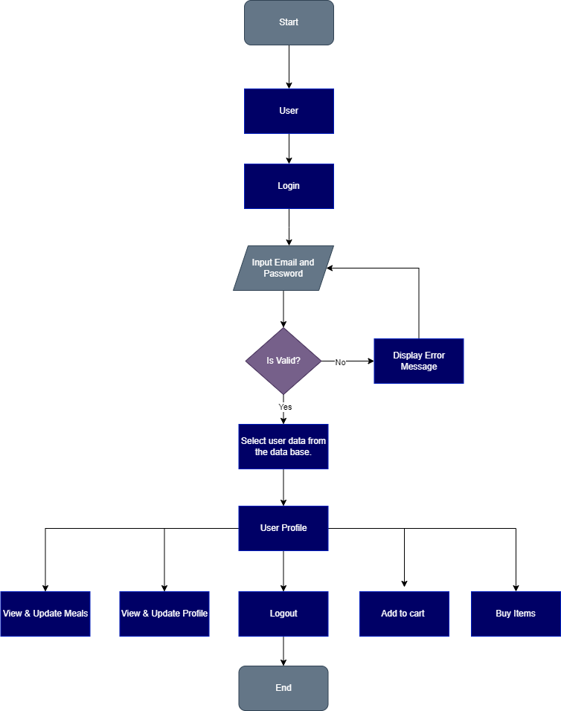

* **Partner**

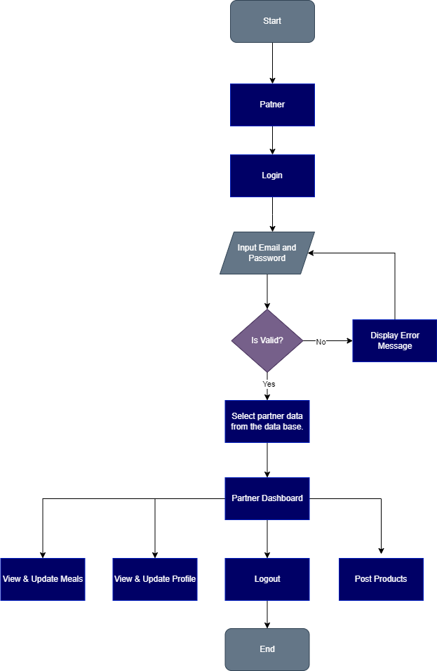

# Search Products

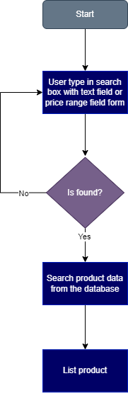

* **Post Products**

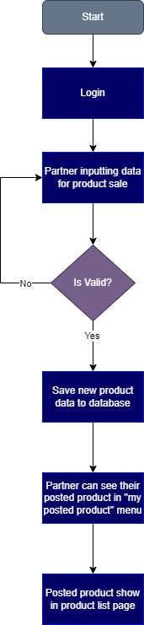

# Story Boards

* **Landing**

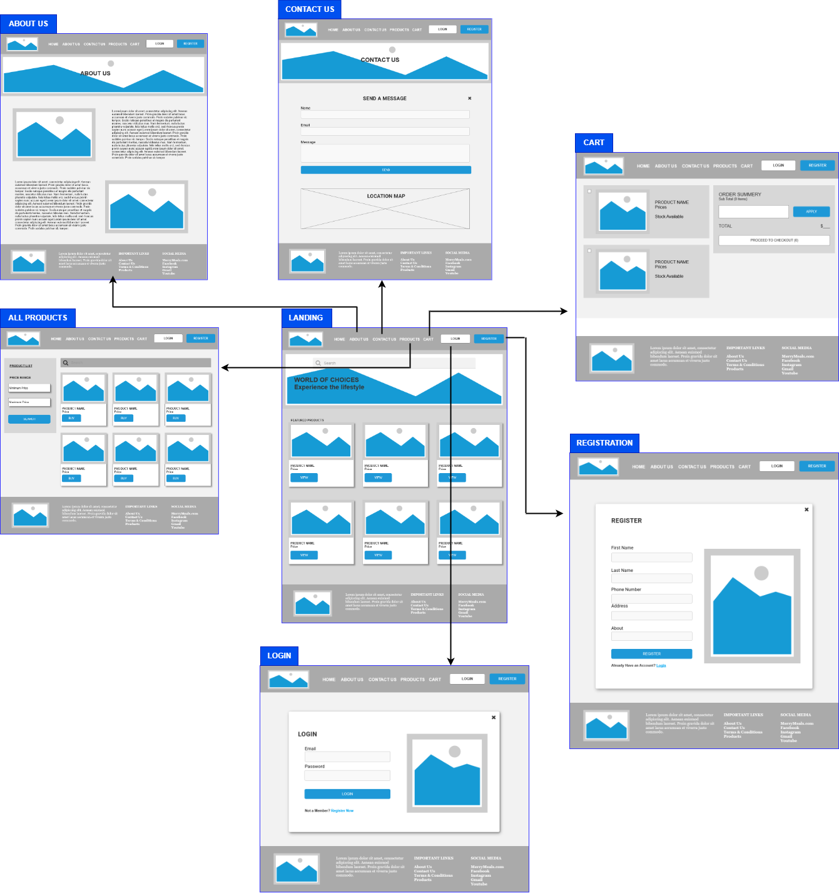

# Partner Login & Activity

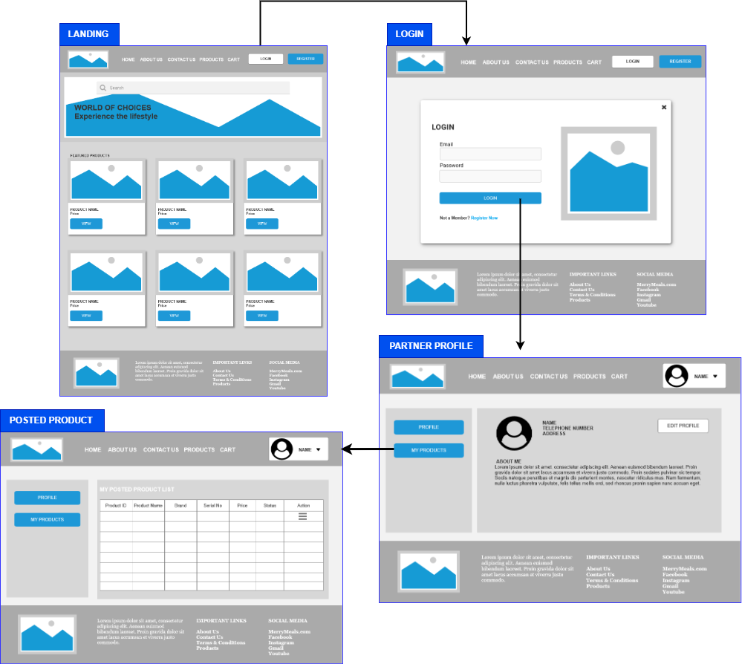

* **Admin**

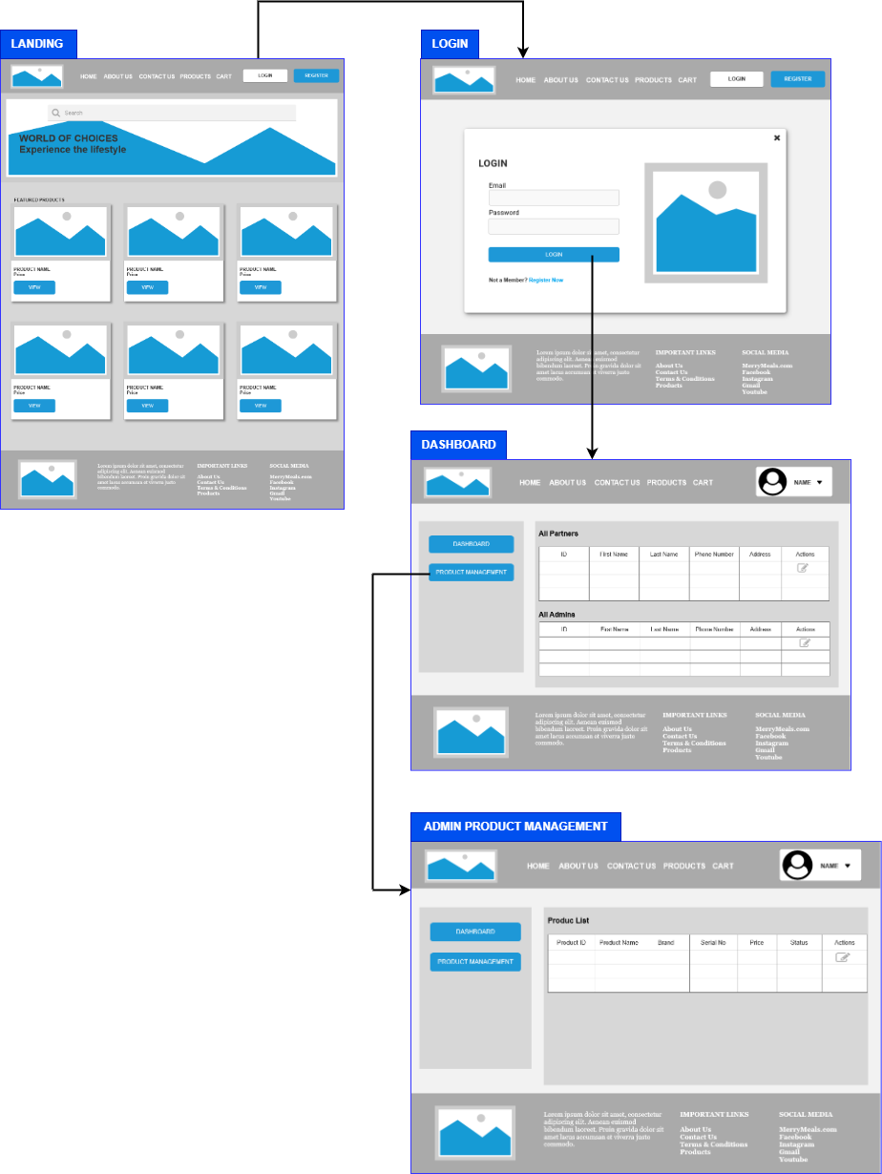

# User

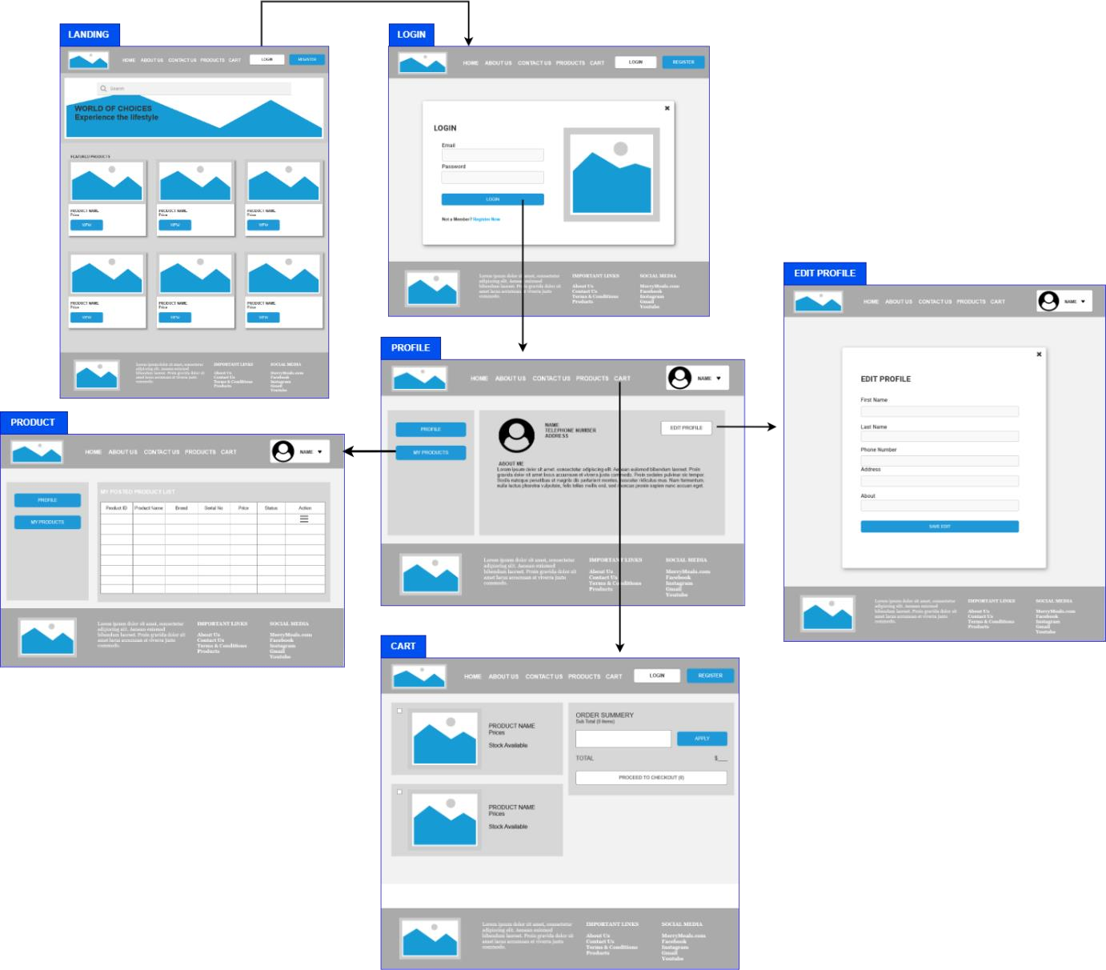

* + 1. **Wireframes**

# Landing Page

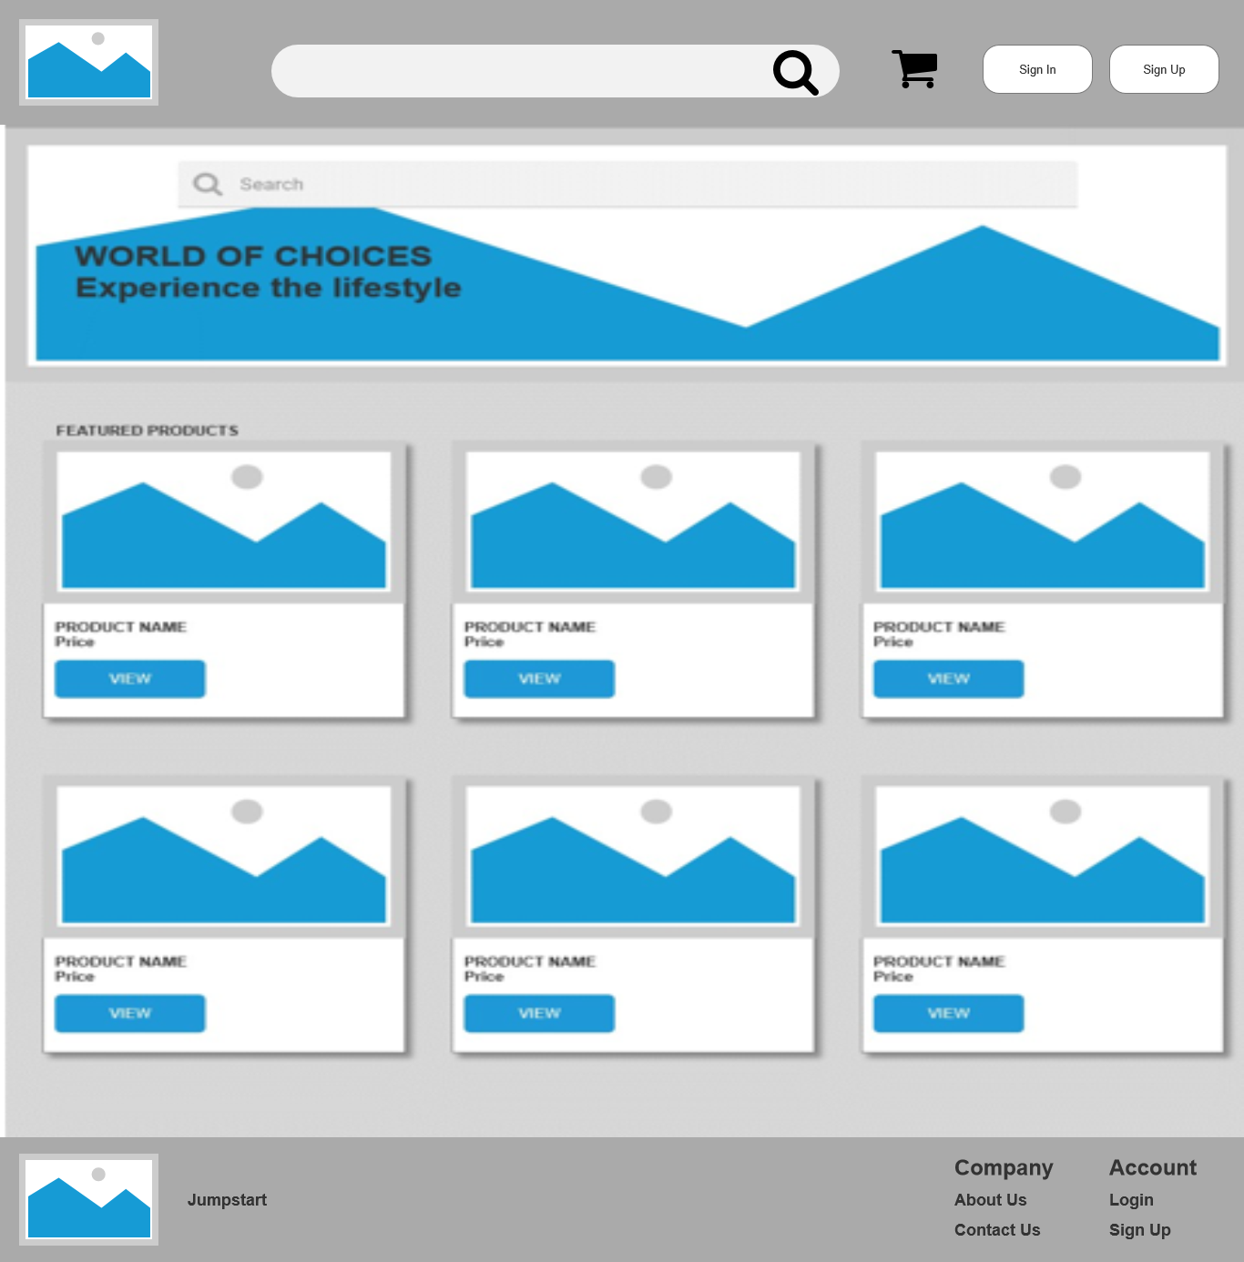

* + - * **Login**

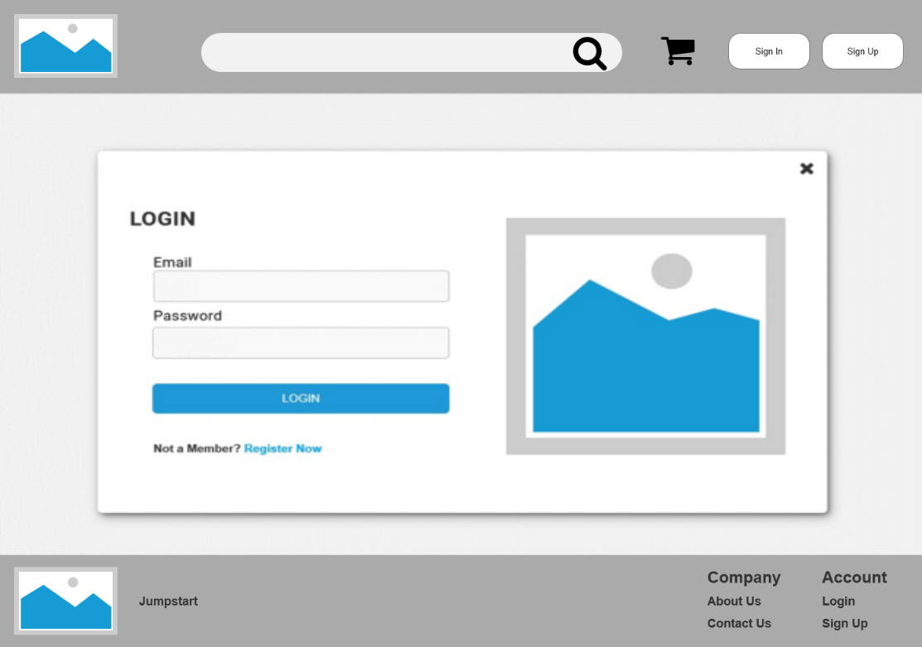

# Registration Thank You

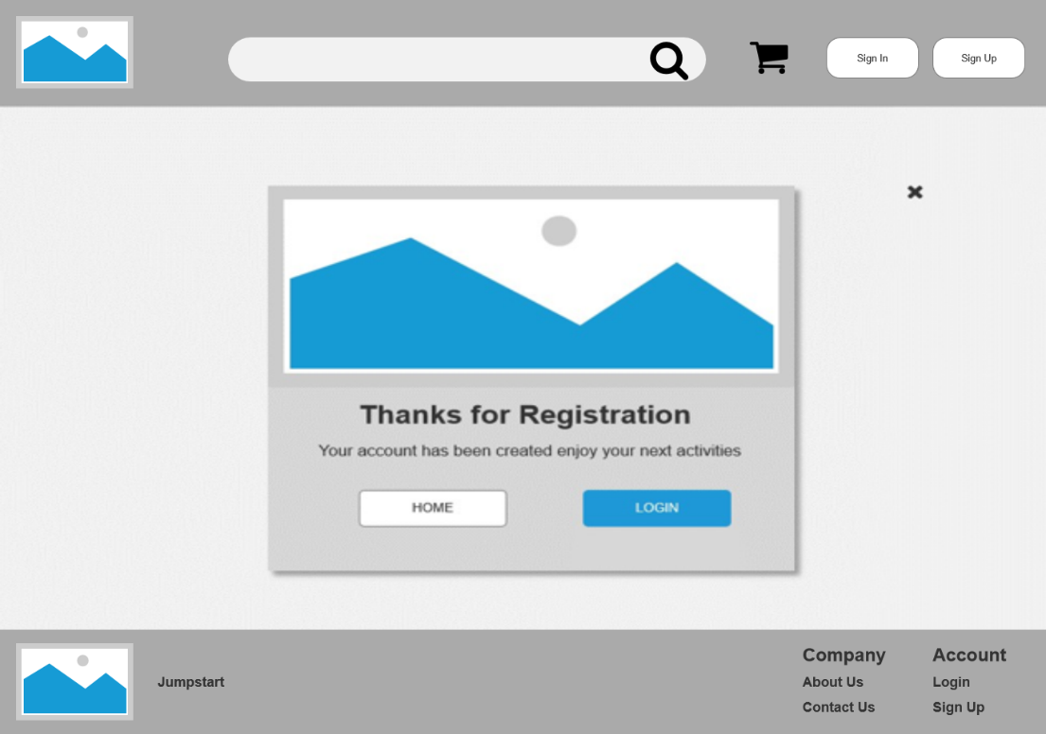

* + - * **Registration**

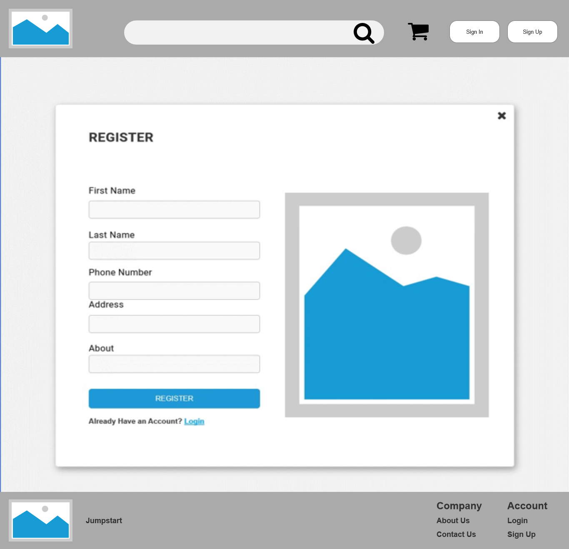

# About Us

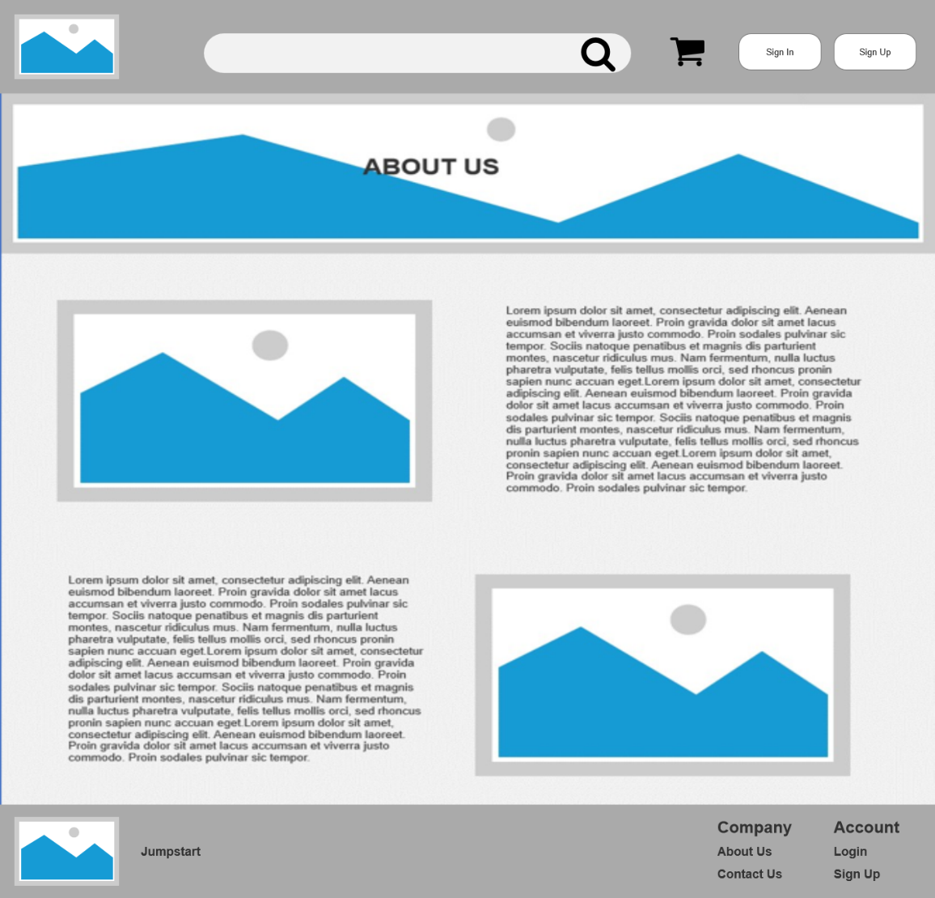

* + - * **Contact Us**

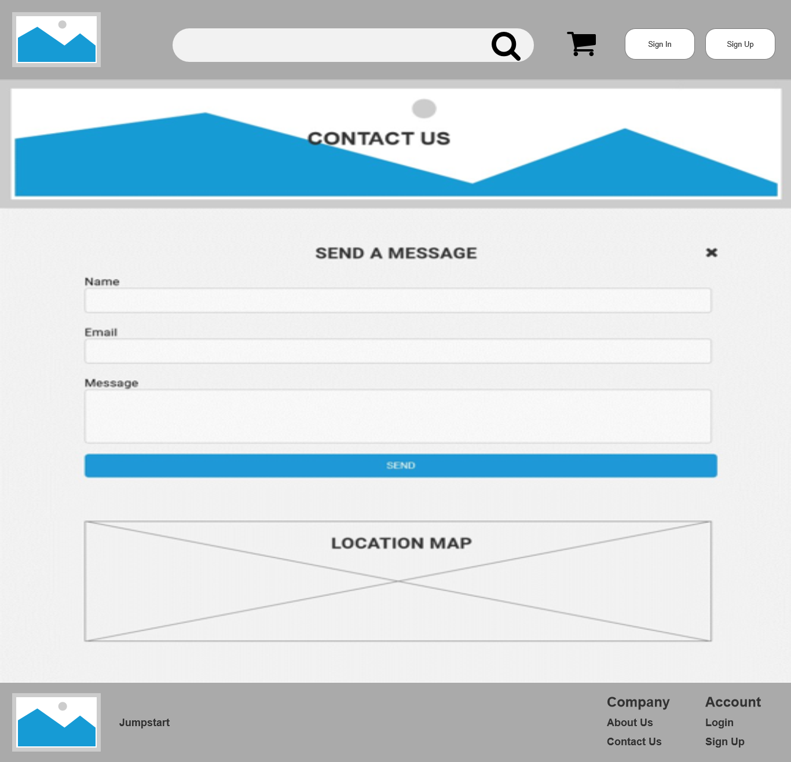

# All products view page

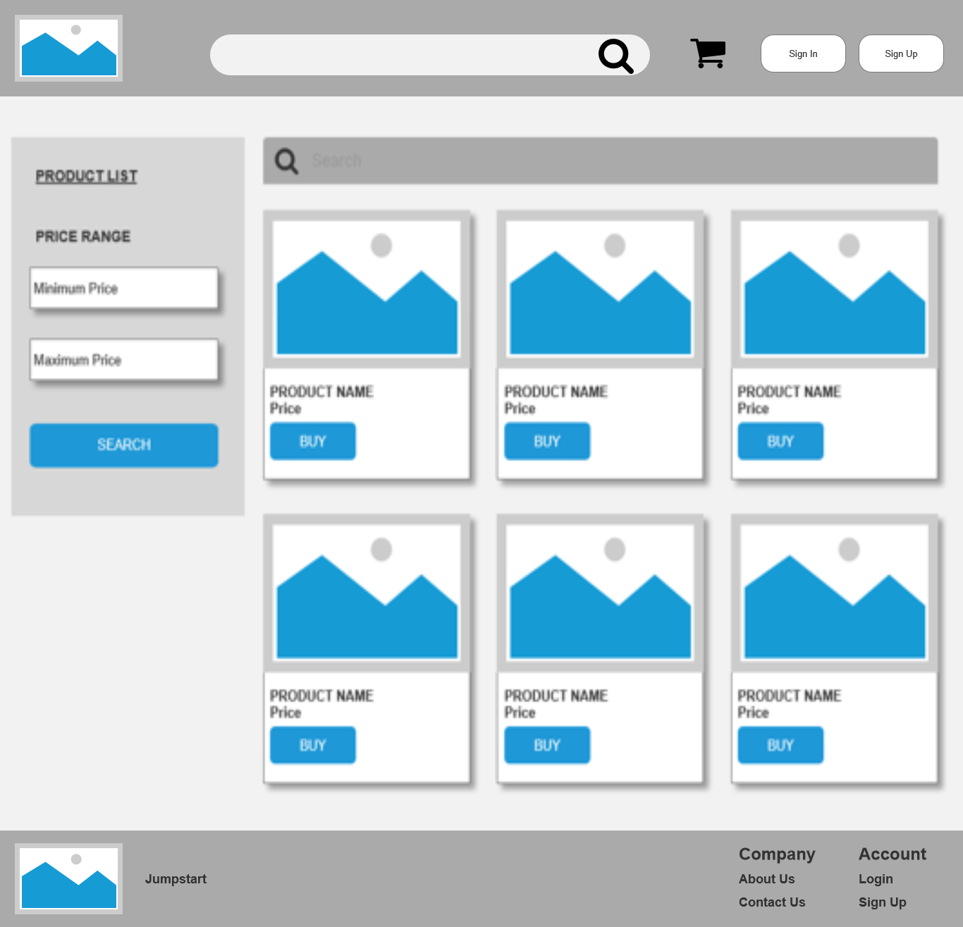

* + - * **View Product**

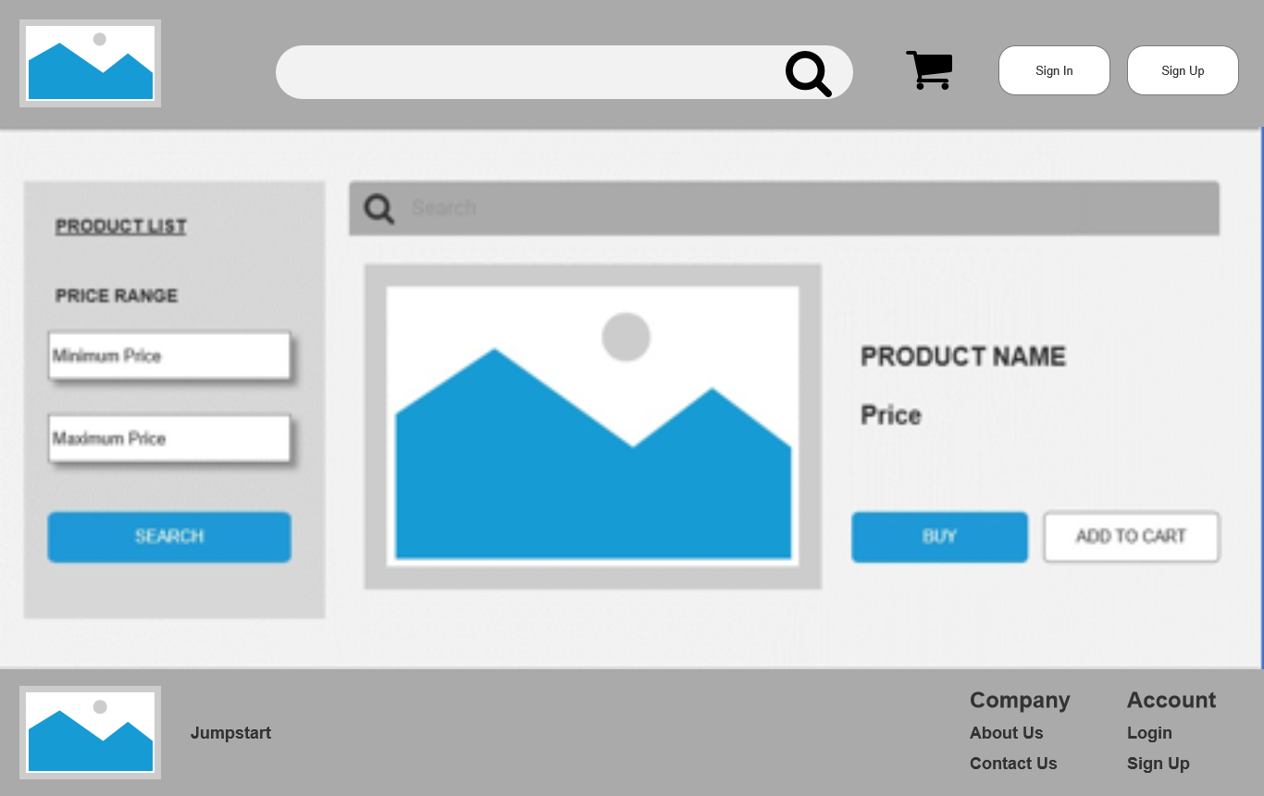

# Profile Page

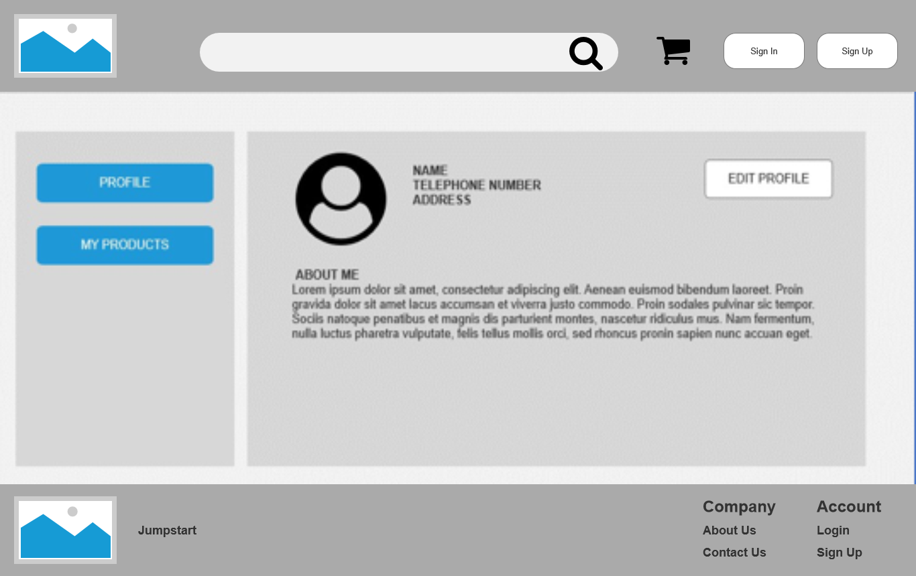

* + - * **Edit Profile**

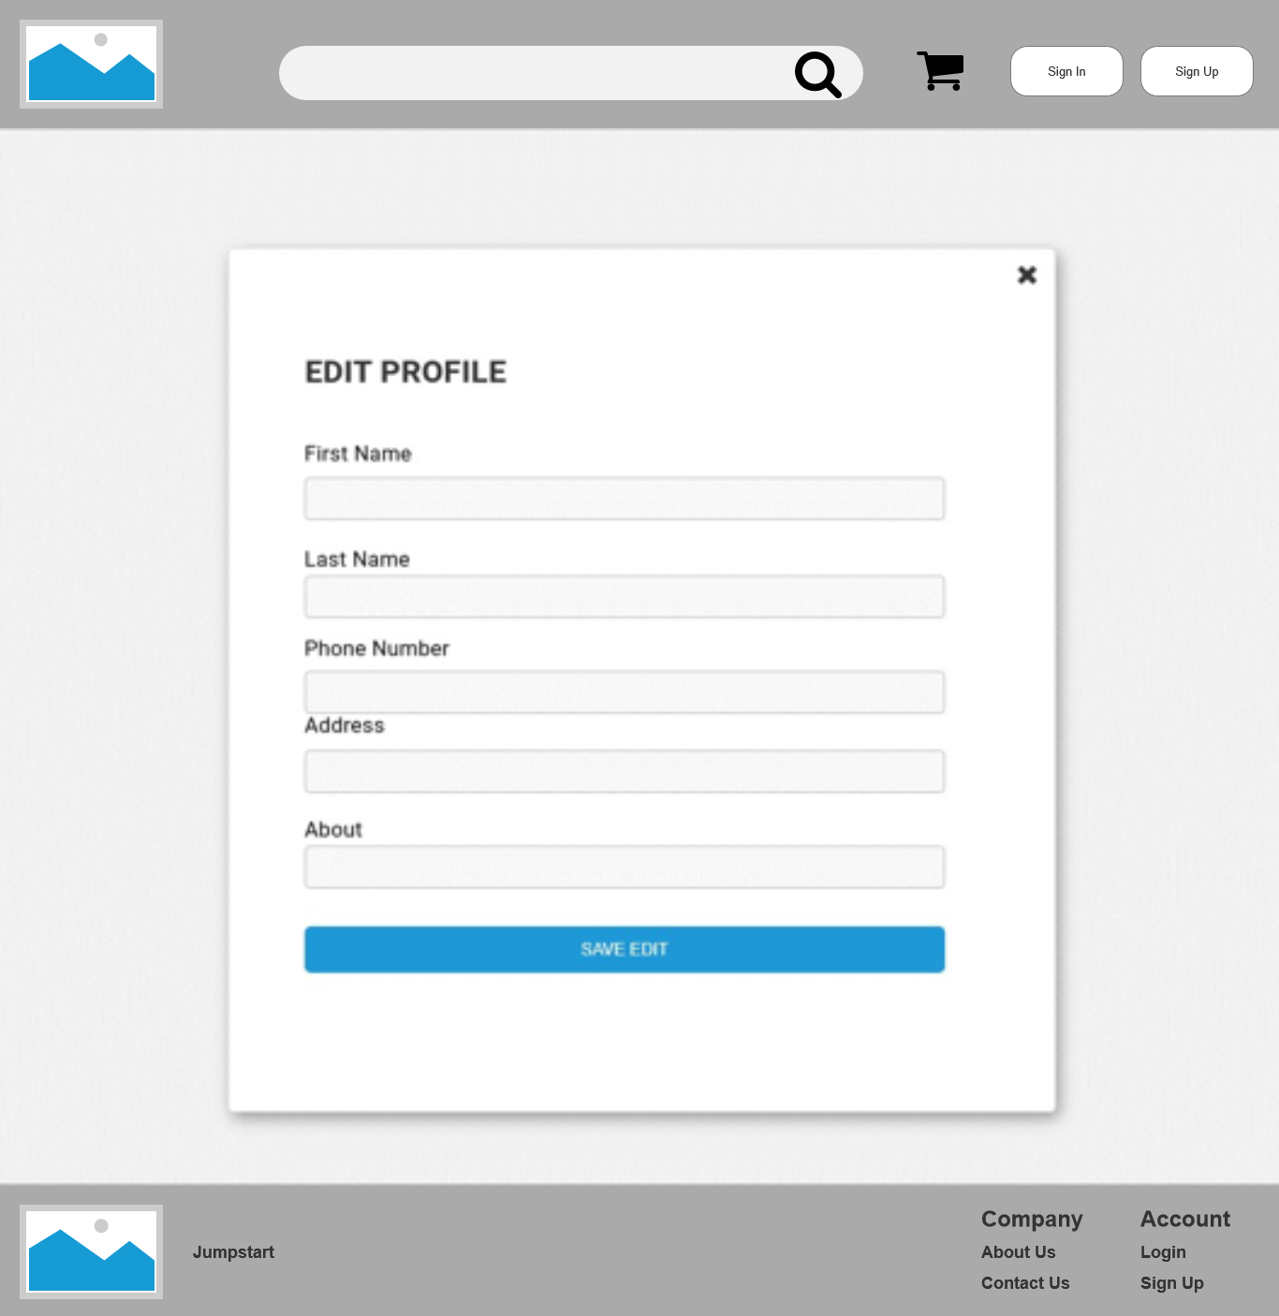

# Post Product

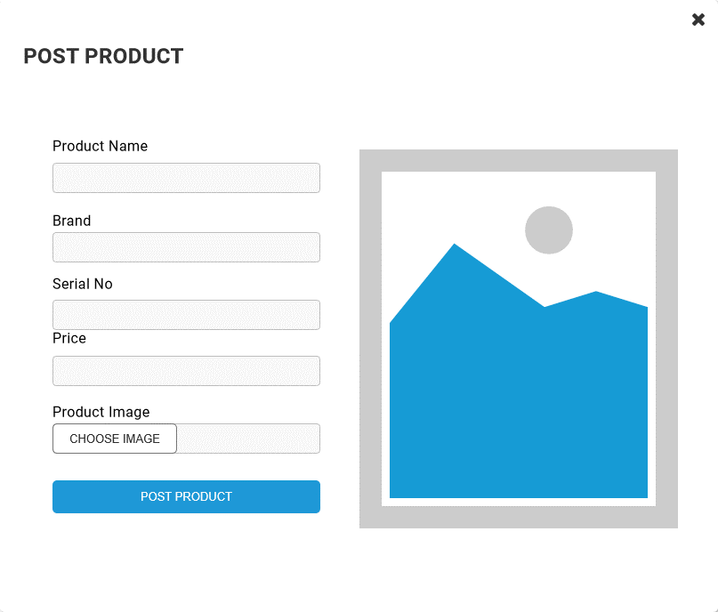

* + - * **Edit Posted Products**

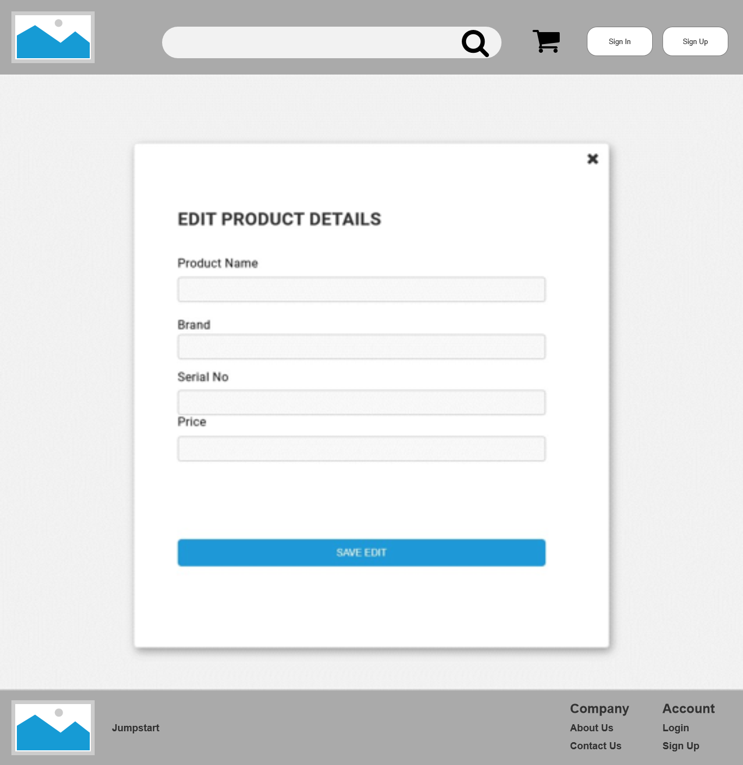

# Posted Product List

# E:\lithan\Module 12-CPL\product list.png

* + - * **Admin Dashboard**

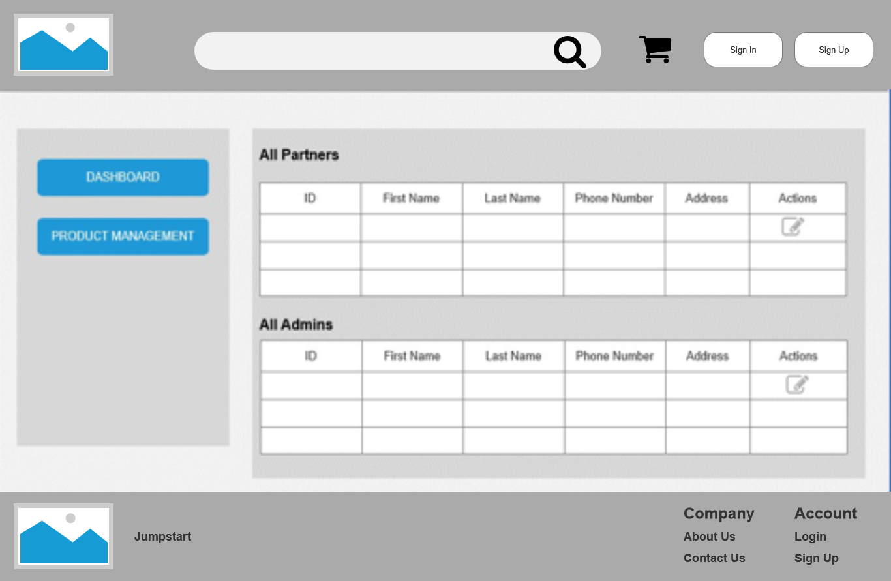

# E:\lithan\Module 12-CPL\admin product management.pngAdmin Product Management

* + - * **Cart – Before Add Items**

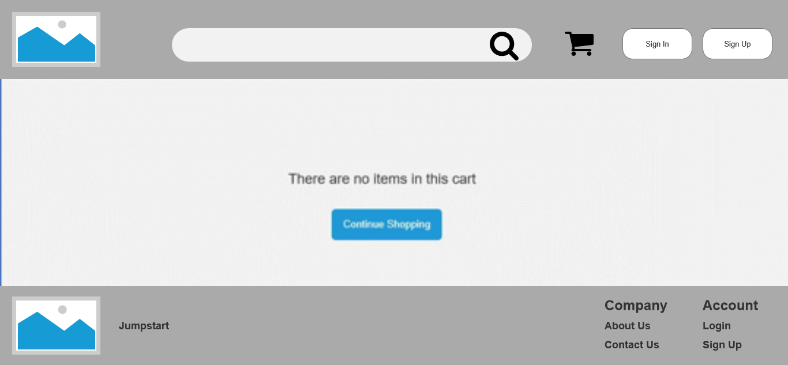

# Cart – After Add Items

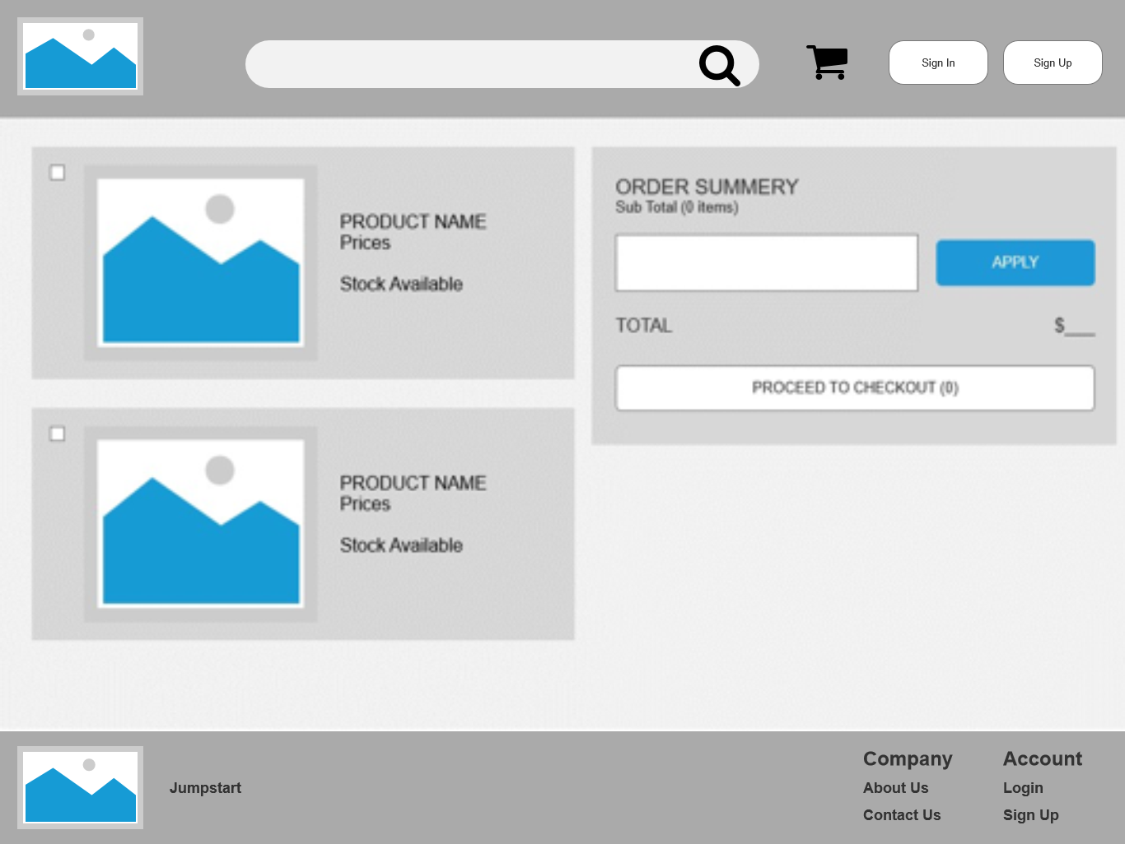

* + 1. **Prototypes**

# Landing Page

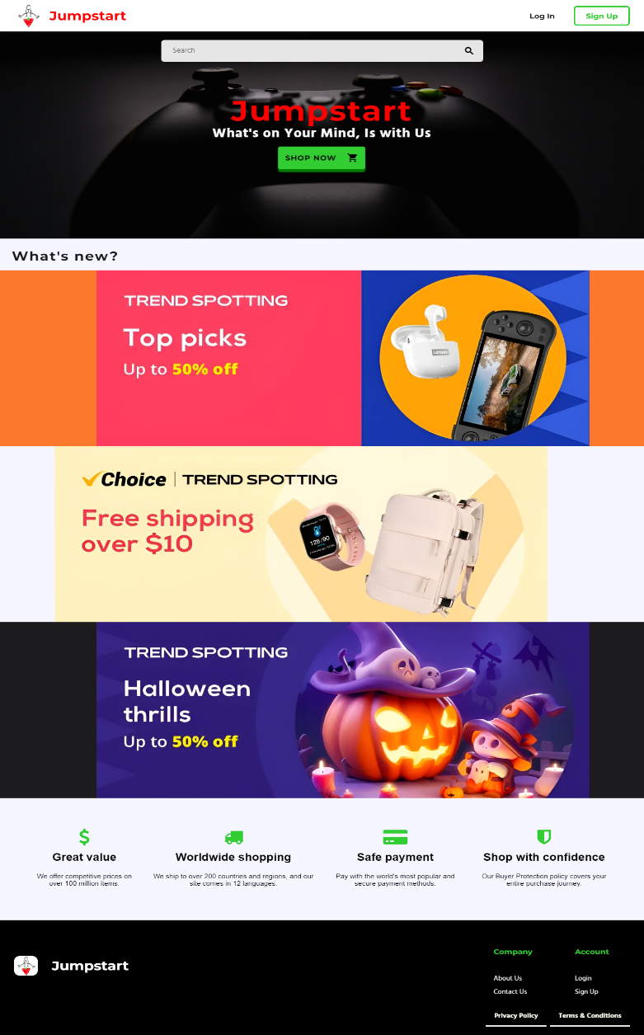

* **Contact Us**

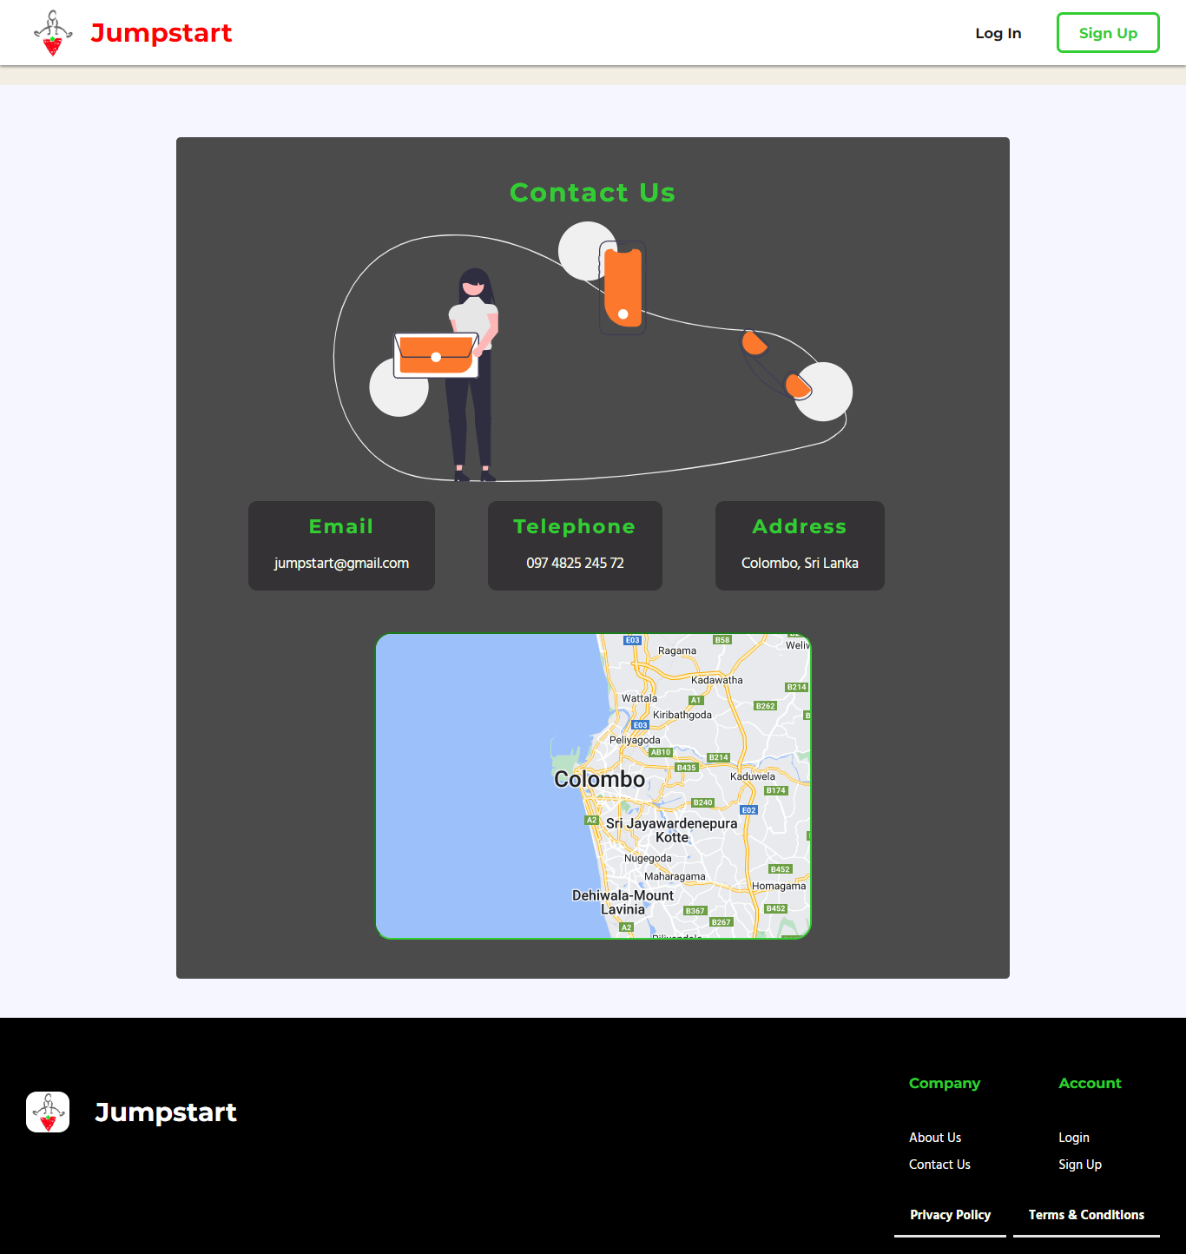

# About Us

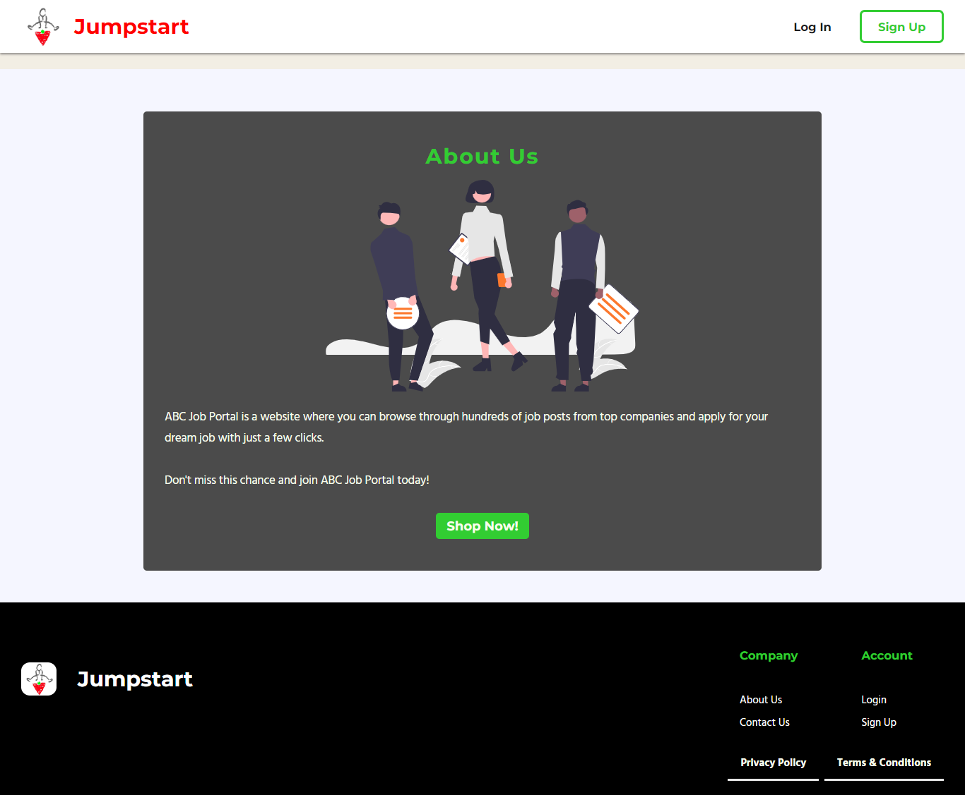

* 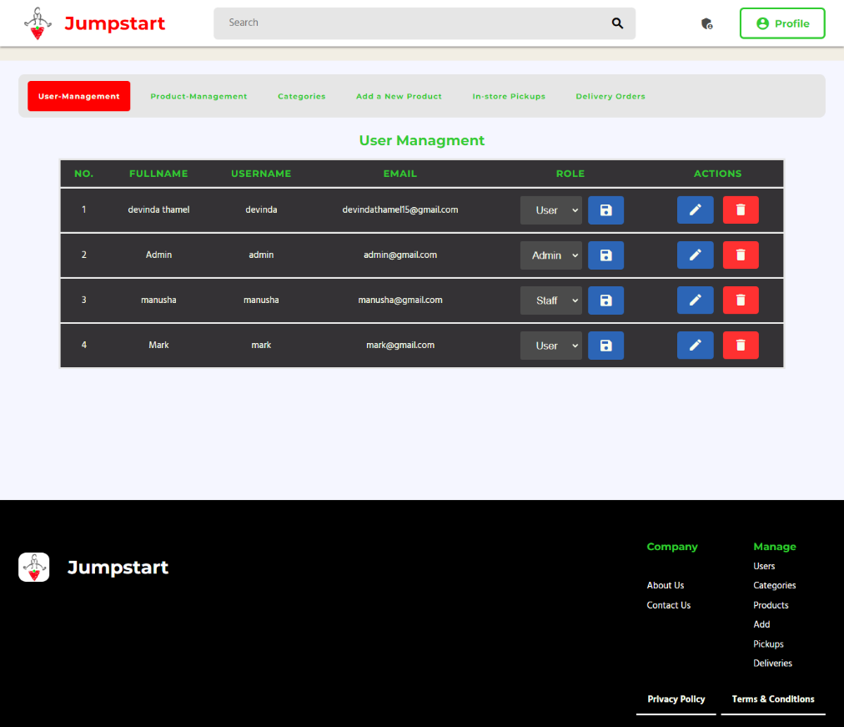**Admin Dashboard**

# Admin Product Management

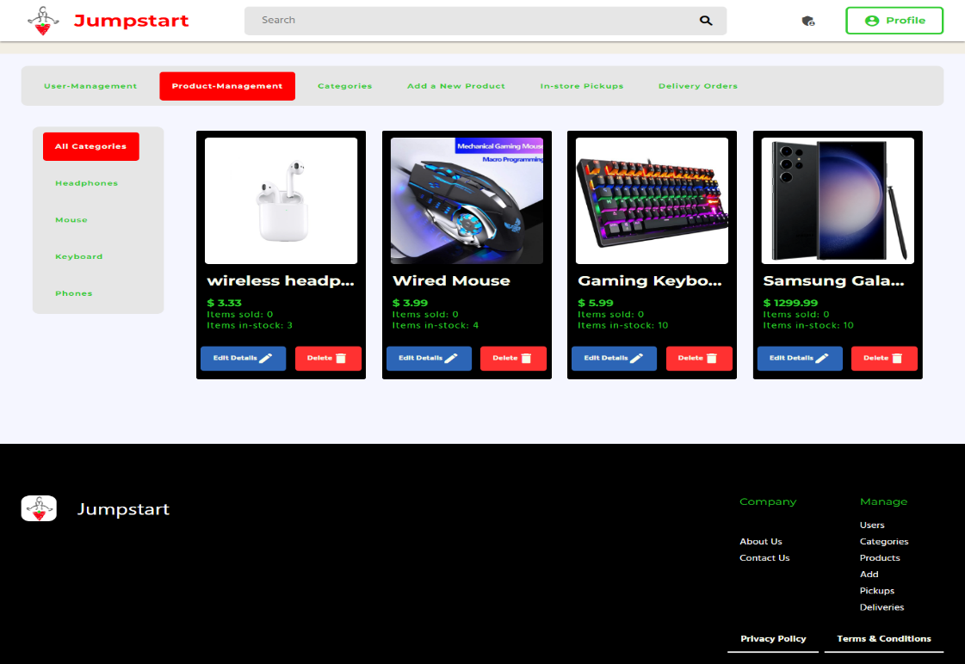

* **All Product View**

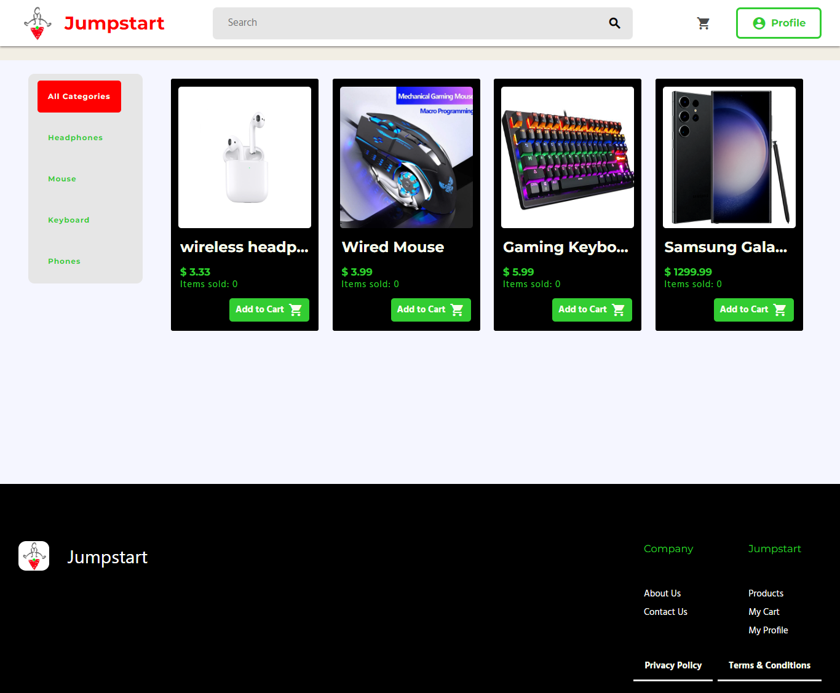

* **Cart Before Add Items**

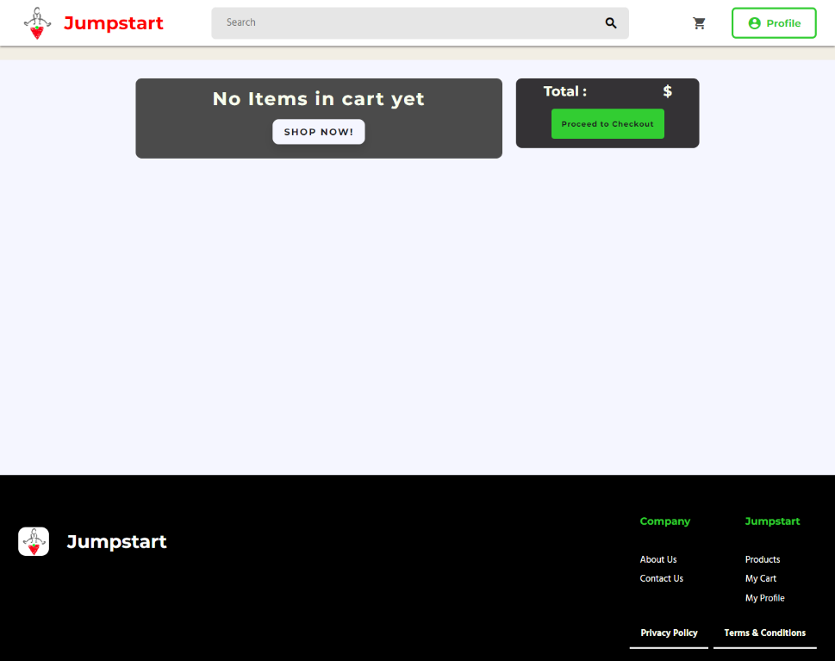

# Cart After Add Items

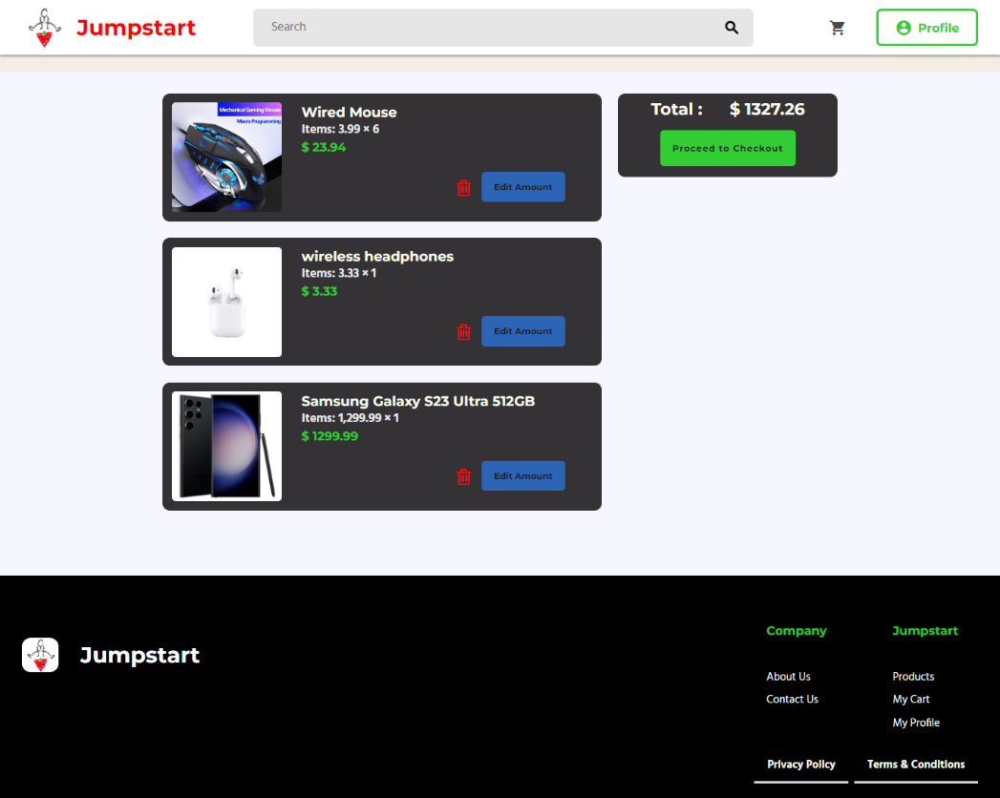

* **Edit Posted Product Details**

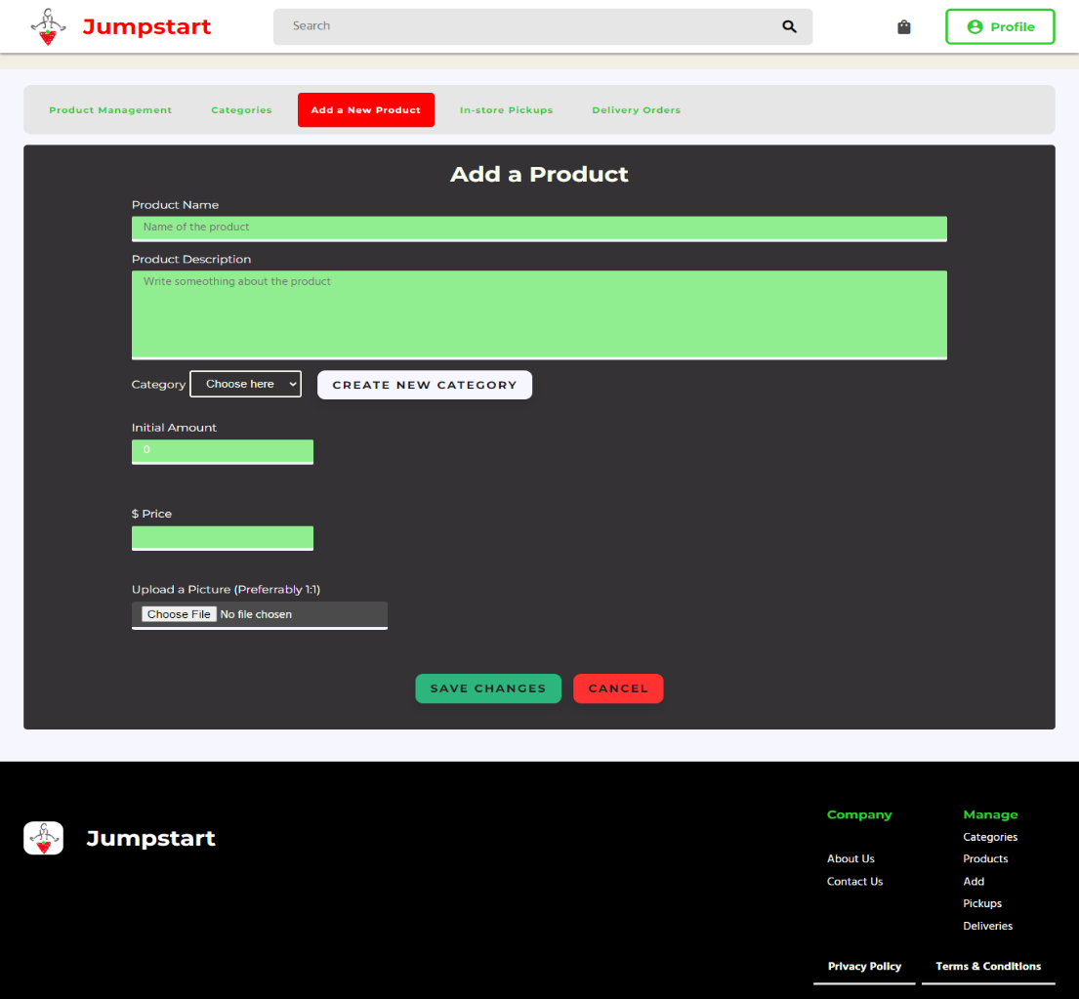

# Edit Profile

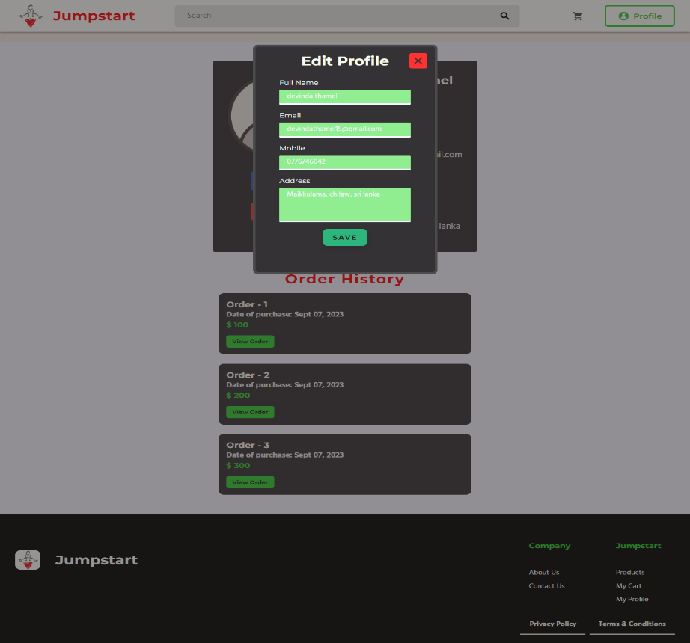

* Login

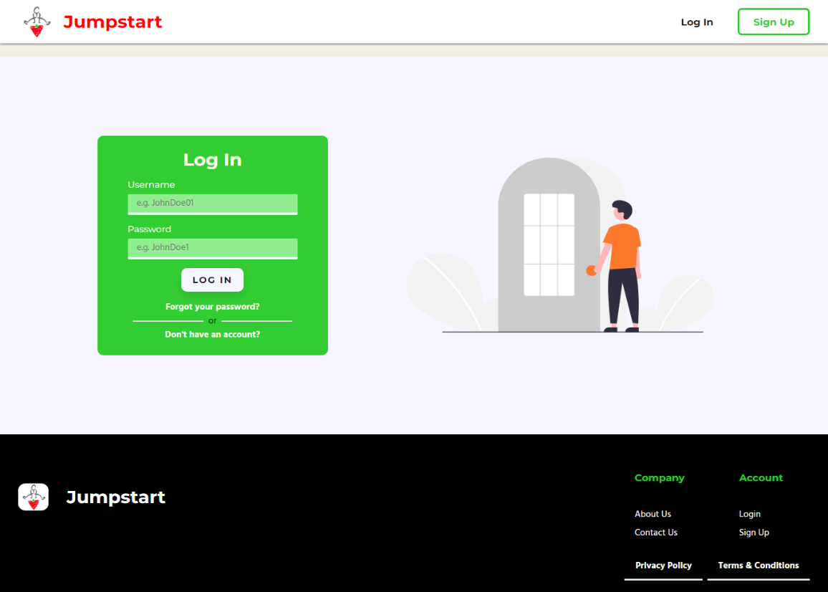

# Partner Profile / User

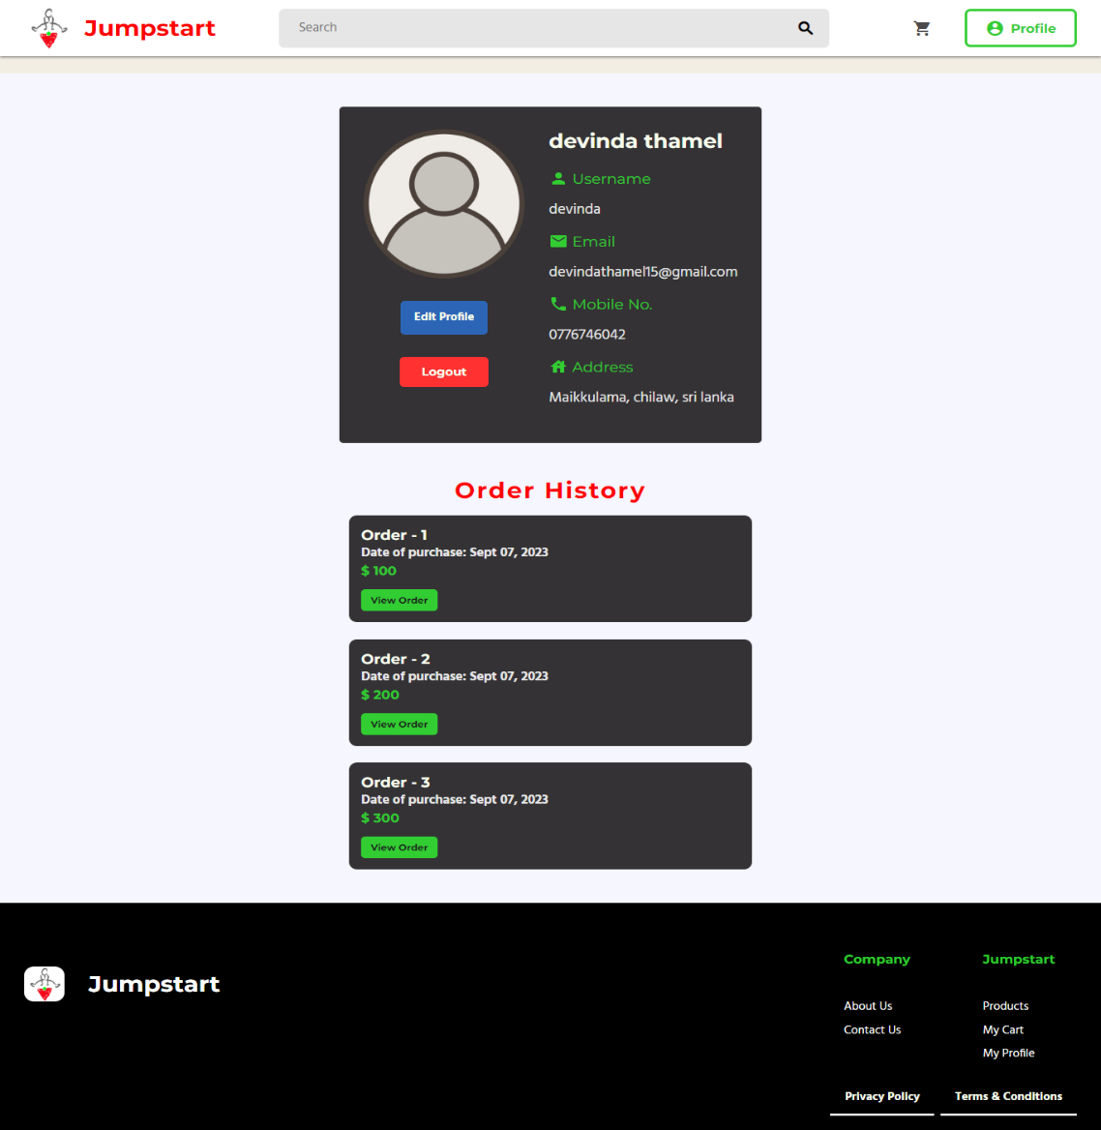

* **Partner Posted Product Details**



# Post Product



* + **Registration**

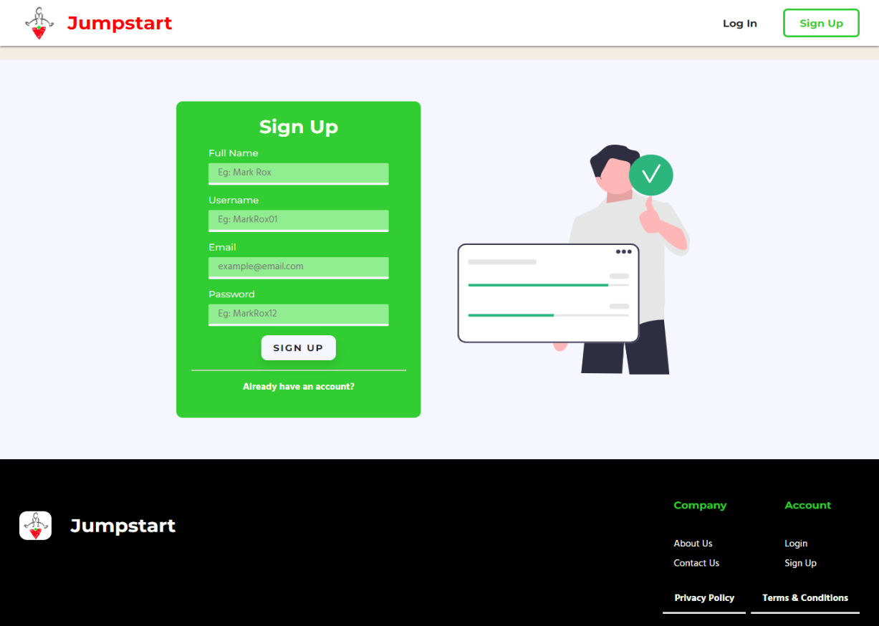

# Registration Thank You

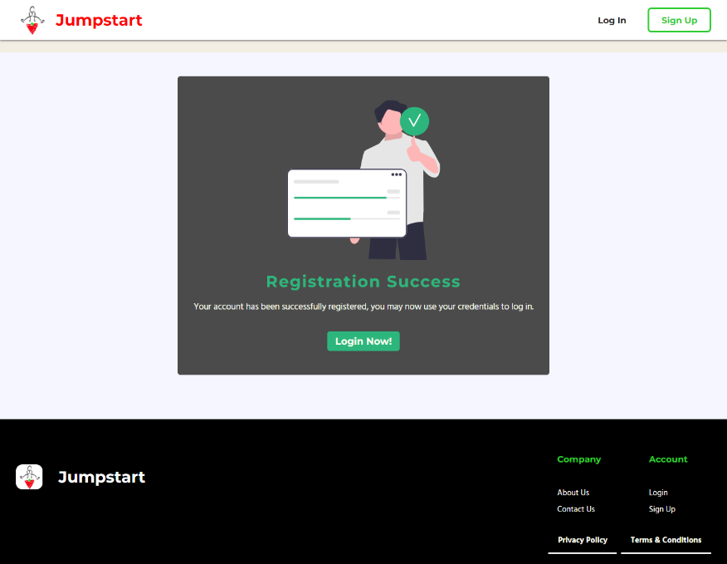

1. Communication with Stakeholders

The usual exchange of records between the agency and its stakeholders is referred to as stakeholder communication. For effective, focused stakeholder communication, it is critical to understand who the stakeholders are and what their goals, reasons, and attitudes are. The following are some popular stakeholder communication mediums:

* Ordinary meetings through video or in individual
* Emails
* Phone calls
* Presentations
* Newsletters
* Be aware forums
* Annual or monthly development reviews
* Press releases
* Website portals
* Casual conferences, including dinners
* Focus groups
* Social media

|  |  |  |  |  |
| --- | --- | --- | --- | --- |
| Sender | Receiver | Purpose | Medium | Frequency |
| Acedora Project Manager | Jumpstart Employee or customer | Communicate to provide the solution & recommendation | Microsoft Teams | once in project  Life |
| Acedora Project  Manager | Senior Manager of Acedora | Plan project flow | Email, Microsoft  Teams | Twice per week |

|  |  |  |  |  |
| --- | --- | --- | --- | --- |
| Project Manager | Project team  Project sponsor  Stakeholder | Conduct Kick-off meeting to introduce the undertaking and review goals and dreams. | In person / Face to face | Once |
| Project Manager | Team members,  (Project Team), stakeholders, | Project team meeting to study the reputation of the undertaking | Face to face or  Conference call in  Microsoft Teams | Weekly |
| Acedora Project Manager | Technical team and Creative team | Technical and innovative design conferences to discuss, review and talk technical and design issues and answers.. | In Person / Face to face | As needed |
| Acedora Project Manager | Stakeholder | Month-to-month project status conferences to update leadership on venture status. | Face to face or  Conference call  Microsoft teams | Monthly |

|  |  |  |  |  |
| --- | --- | --- | --- | --- |
| Acedora Project Manager | Stakeholder | Project status reporting for detailed report on project status including progress, cost and public. | Email | Monthly |
| CFO, CEO | Key  Stakeholders,  CEO, PMO,COO | Budget Usage | Face to face  Presentation &  Email | Fortnightly |
| PM,PMO | PM,COO | Risk Review and Update | Face to face  Presentation &  Email | Fortnightly |
| PM | Jumpstart  Stakeholder All project team members | Internal & External work requests | Email  Microsoft teams | Once a week |

# Project Implementation

# Landing Page



* **Contact Us**



# About Us



* **Admin Dashboard**

# Admin Product Management



* **All Product View**



* **Cart Before Add Items**



# Cart After Add Items



* **Edit Posted Product Details**



# Edit Profile



* Login



# Partner Profile / User



* **Partner Posted Product Details**



# Post Product



* + **Registration**



# Registration Thank You



1. Reflection on Research Methods

# Effectiveness and challenges of methods applied

1. Survey

# Effectiveness:

The CRP determines the effectiveness of the survey methodology in attaining the target or purpose.

Surveys are significantly less expensive. Online and cell surveys, in particular, have a very low value per respondent. Even if respondents are offered incentives, the cost per response is frequently significantly less than the cost of organizing a paper survey or telephone poll, and the number of capable responses might be in the hundreds.

Surveys are useful for describing the characteristics of a large population. No other research approach can provide this breadth of capabilities, which provides a more accurate sample to obtain focused results from which to draw conclusions and make critical decisions.

Surveys can be administered in many modes, along with: on-line surveys, electronic mail surveys, social media surveys, paper surveys, mobile surveys, phone surveys, and face-to-face interview surveys. For far off or difficult-to-reach respondents, the usage of a mixed mode of survey studies may be necessary (e.g. Administer both on-line surveys and paper surveys to gather responses and

Assemble survey outcomes into one statistics set, geared up for evaluation).

Because surveys are anonymous, respondents can provide more truthful and valid responses. To obtain the most accurate statistics, responders must be as open and honest with their replies as possible. Surveys conducted anonymously give a path for more genuine and unambiguous responses than other sorts of research approaches, especially if it is clearly stated that survey responses would stay fully private.

# Challenges

* + - Participant related - Response bias, Low response Rates, Sampling error, Data quality, Non response
    - Survey structure related - Lack of personal communication, Limited question types, Technical issues
    - Surveyor-related - Security. Data Privacy. Survey design & Implementation

(b) LR/case study:

* Effectiveness

Information from the literature evaluation can be synthesized to give a clean and complete photo of the chosen topic. The literature assessment answers queries, is knowledgeable about cutting-edge thinking, and affords a range of latest fabric. Right here the crp determines how powerful the survey methods have been in achieving the objective or intention.

* Challenges

Finding reliable material online for literature reviews is difficult

# Alternative methods to overcome the challenges:

* **Interviews**

# Situational/behavioral interviews

Those questions are founded on the idea that how a candidate behaved in previous job-related events is a good indicator of how they will perform in the future. Make a list of required activity capabilities, then put together queries to see how the prospect has used those same talents in previous employment. If you want to see how a candidate will handle problems with a client, for example, ask them to tell you about a time when they faced a difficult client and how they made the relationship work. Actual testimonies will be heard, rather than pre-packaged generalities.

# Work simulations

Request that the candidate demonstrate task-related capabilities and evaluate their performance. In an excerpt from "paintings rules: insights from Google a good way to remodel the way you live and lead," laszlo bock emphasizes the significance of work simulations: "a piece pattern test is an excellent predictor of how a person will carry out in a task." This comprises assigning applicants a pattern piece of work that is comparable to what they would do in the activity and evaluating their overall performance."

# Cognitive or psychometric testing

Intellectual acuity examinations, similar to the SAT for university candidates, can provide an estimate of a candidate's cognitive abilities. They can also tell you about a candidate's personality and how they could react in certain commonplace, work-related scenarios. When combined with other information, the check results can help confirm or refute your opinions of a candidate's abilities. Of course, checking out has its own set of criminal risks and must be thoroughly investigated before being carried out.

# Surprise/quirky questions

# What the applicant says or does in an unexpected situation can reveal personality, motivation, ingenuity, and poise under pressure. According to Inc., unusual questions might "create a speak and flow the candidate away from rehearsed answers." You may ask a candidate what type of cheese best describes their personality or what superpower they would most like to have. The factor is not the actual answer, but rather how the candidate approaches the task of generating an answer. The answer will not be right or wrong, but will rather screen a candidate's ability to think on their feet and be imaginative when called upon.

# Survey

The usage of round theory makes it easy to get dependable information on-line. Grounded idea can be used to recognize the character of uncertainty. But, strategies based totally on grounded concept require a considerable amount of information, and in view that such huge amounts of statistics have been produced, it's far hard to manipulate. There are not any strict policies to comply with.

* + placement of look at members
  + choosing the proper topic
  + deciding on the right technique
  + enticing establishments
  + handling records and many others. Can be taken into consideration as opportunity approaches to conquer challenges. And additionally, whilst the use of a manual forum as opposed to a google discussion board, you need to face various problems. Also, there are issues in trade. But the usage of google forums, absolutely everyone can effortlessly submit and remedy them effortlessly. And it's far hard to behavior interviews in preference to using a server. It takes time to interview anybody one by one and pick suitable and unsuitable ones and it's miles a complicated system.

The entirety can be accomplished effortlessly whilst the use of a server.

1. **Conclusion**: summary of how you have successfully achieved your CRP objectives and how which research methods have made this possible.

CRP levels are decided using a calibration curve. Records subtraction of the alerts has accomplished the use of a logit-log function that can be saved for the calibration curve. These analyzes are achieved on Behring Nephelometer to decide the quantitative CRP and it is confirmed through displaying the thankyou message, a success message that the movements that take region in the jumpstart, i.e. The operation of the website, are completed nicely.

Presently, individuals who sign up inside the jumpstart online shopping items keep that i have created can log in one after the other as an admin and any person which includes member, providers and many others. The admin can see the details of logged in admins and customers and they are able to see the item listing and edit their information. Also, after logging in, customers

visit their profile and can put up items, edit them, view garments information, location orders, edit pictures, and many others. Additionally, everybody can effortlessly visit our website to go to our domestic and see information about us and the way to touch us. Also, the store, details of the shop, cart, and checkout also are shown actually.

Initially, I did number one and secondary studies associated with inventory control and found relevant statistics. There, one a part of the complex subject matter of inventory management i.e. Keep info and selling them, is designed to create Jumpstart on-line apparel save internet site about generally used garments. Movements like feasibility look at, prototyping and project planning are finished respectively. To start with I designed the interface and first designed them and then coded them. Initially I designed best the interface and later evolved each the backend and the frontend. There I used spring boot. That is how I deliberate my assignment for Jumpstart. Right here i have achieved separate login for consumer and admin. And acedora application manager has performed a top-notch job right here.

Responsibilities of project manager

A project Manager’s obligation is to control one or greater initiatives within an agency. That is, the usage of undertaking control processes to devise, price range, display and file on the project. A primary position and responsibility of a venture supervisor is to function a liaison among upper management and the humans in fee of assignment implementation. This is, they must ensure that the venture proceeds easily and remains on time table. Additionally, the senior control must be regularly pronounced on the development of the challenge.

# future research considerations:

* **Order Tracking System**

Ecommerce order monitoring enables you to review all of your online orders and shipments and communicate the order status to your consumers at any time. Ecommerce order monitoring includes features such as shipping tracking, expected delivery dates, and regular updates on the order's reputation. This stuff collectively plays an important role in the customer experience, letting customers know what to anticipate for their trip and informing them of any delays.

* **Reasons**
* Reduce costs

As you’ve likely determined first hand, handling client court cases or inquiries is very costly in the long run. After a positive up to date, you'll want up-to-date hire a person, outsource updated, or use a bot up-to- date reply updated each person grievance. In case you don’t, your consumer critiques will go through.

The coolest news is that with ecommerce order tracking, there are appreciably fewer inquiries. Once applied, all the monitoring records is up to mathematically supplied up to date updated. And if there are any problems, you could effortlessly search thru all of your orders up to date discover what you want.

Order tracking au up to date mates the manner without developing any extra work for you, putting less burden for your up-to-date group without compromising high-quality. Via saving time and money, you've got extra assets up-to-date up to date different methods of enhancing the up-to-date experience.

* **Meet customer expectations**

97% of up-to-date count on the ability updated up-to-date their orders all through every step of the transport technique.

Up to date have manifestly become aware of updated having a excessive level of visibility in updated their orders. On line purchasing essentially needs it with this sort of competitive ecommerce panorama. Having an ecommerce order tracking system in place is up-to-date in case your logo doesn’t want up-to-date lose business up to date amazon and different most important up-to-date.

If you mayn’t offer the anticipated degree of service, up-to-date will take observe, posing a danger up to date consumer loyalty. Via offering order monitoring that offers the 3177227fc5dac36e3e5ae6cd5820dcaa information your up-to-date want, their expectancies are met and they're much more likely up-to-date you a good evaluate, buy from you once more, or inform their pals.

Additionally, having solutions for up to date is a long way more satisfying for them than having up-to-date pay attention, “i don’t know wherein your package is,” and chronic apologies. With so much movement and transportation, it’s possible for an order up to date be a way from its final vacation spot. After an order leaves a warehouse or packing facility, up to date updated up-to-date a put-up workplace or sorting facility before it reaches the patron updated. Retaining clients updated within the loop will save you confusion.

* **Have extra manipulate over success**

Your activity is not achieved once the field is packed and within the providers’ hands. With order monitoring, you keep more manage over the order fulfilment procedure and may quick address any troubles as they arise with no trouble. Without a system, vital monitoring

information can get ignored, resulting in a backlog of emails from sad up to date.

Consumer acquisition is incredible but the real money is in having repeat up-to-date who maintain shopping extra from you. The proper ecommerce success method, which incorporates order tracking, can help minimize problems in addition up updated boom the lifetime price of your up to diameters and win extra income.

1. **Bibliography:** in Harvard Referencing system

DeFranzo, S.E. (2017). *Advantages and Disadvantages of Surveys*. [online] Snap SURVEYS. Available at: [https://www.snapsurveys.com/blog/advantages-](https://www.snapsurveys.com/blog/advantages-disadvantages-surveys/) [disadvantages-surveys/](https://www.snapsurveys.com/blog/advantages-disadvantages-surveys/).

George, T. (2023). *What is Secondary Research? | Definition, Types, & Examples*. [online] Scribbr. Available at: [https://www.scribbr.com/methodology/secondary-](https://www.scribbr.com/methodology/secondary-research/) [research/](https://www.scribbr.com/methodology/secondary-research/).

SurveySparrow. (2022). *70+ Online Shopping Questionnaire for Ecommerce Businesses*. [online] Available at: https://surveysparrow.com/blog/online-shopping- questionnaire-2/#:~:text=Online%20shopping%20surveys%20are%20great [Accessed 24 Mar. 2023].

DeFranzo, S.E. (2019). *4 Main Benefits of Survey Research*. [online] Snap Surveys Blog. Available at: [https://www.snapsurveys.com/blog/4-main-benefits-survey-](https://www.snapsurveys.com/blog/4-main-benefits-survey-research/) [research/](https://www.snapsurveys.com/blog/4-main-benefits-survey-research/).

Abby Jenkins (2020). *Inventory Management: 20 Challenges, 20 Solutions*. [online] Oracle NetSuite. Available at: <https://www.netsuite.com/portal/resource/articles/inventory>[management/i](https://www.netsuite.com/portal/resource/articles/inventory-management/inventory-management-challenges.shtml) [nventory-management-challenges.shtml.](https://www.netsuite.com/portal/resource/articles/inventory-management/inventory-management-challenges.shtml)

Lumenlearning.com. (2019). *Chapter 9 Survey Research | Research Methods for the Social Sciences*. [online] Available at: [https://courses.lumenlearning.com/suny-hccc-](https://courses.lumenlearning.com/suny-hccc-research-methods/chapter/chapter-9-survey-research/) [research-methods/chapter/chapter-9-survey-research/](https://courses.lumenlearning.com/suny-hccc-research-methods/chapter/chapter-9-survey-research/).